Multimedia

Review of Gut Botany by Petra Kuppers.

Wayne State University Press (2020)
Maria Teresa Houar
University of Hawaii at Manoa
Hawaii, United States
Abstract
A book review by Maria Teresa Houar of Petra Kuppers’ collection of new and recently published poetry Gut Botany (2020).
Keywords: poetry, disability, sexuality, trauma, environment

So I sit down and write, palm tingling with the bark’s rough tongue.
--Petra Kuppers, “Wild Tongue,” Gut Botany

In Gut Botany, disability culture activist and artist Petra Kuppers offers a collection of new and recently published poetry, inviting readers to journey through a sensuous, textual mapping of her settler body in relationship to the Indigenous lands of Turtle Island (the North American continent). Her writing presents experiences of sexuality, sexual trauma, and healing as themes which traverse many terrains throughout the text. These regions include the wildness of the Pacific Northwest and Great Lakes, the inside of a courtroom, a craniosacral
Figure 1
Excerpt, “Contours”. From Gut Botany (p. 16), by Kuppers, P., 2020, Wayne State University. Copyright 2020 by Petra Kuppers.
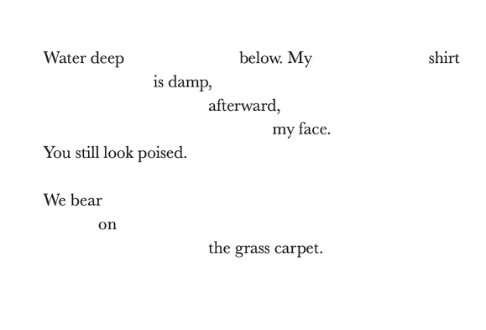
therapist’s table, the contours of a lover’s body, the contact point between tectonic plates, and the topography of a wheelchair. All become the landscapes through which we witness Kuppers celebrate the vulnerability of diverse living bodies.
Kuppers’s poetry invites the reader to consider the sensual possibilities within the environmental motifs of water (ice, fish, sex, gut, delta, tears), land (mountain, belly, rock, pelvis, earthquake, skin), and atmosphere (sky, ancestors, wind’s curvature, murmurs, moon, spirit). As the text carries us into intimate proximity with the abject and divine, she collapses any boundaries which would have us understand these experiences as discrete phenomena. In doing so, the volume engages readers in a revaluing of the“ gut” as an image of vulnerability which might come to redefine our notions of desire and erotic power. Beyond the gut biome (a natural habitat for intestinal microflora, viscera, and waste) exists Gut Botany, offering itself as a study of relationships, the practice of vulnerability, and a renewed vision of existence within economies of intimacies, interdependence, and care.
Figure 2
Excerpt, “Poet Drag Kings”. From Gut Botany (p. 80), by Kuppers, P., 2020, Wayne State University. Copyright 2020 by Petra Kuppers.
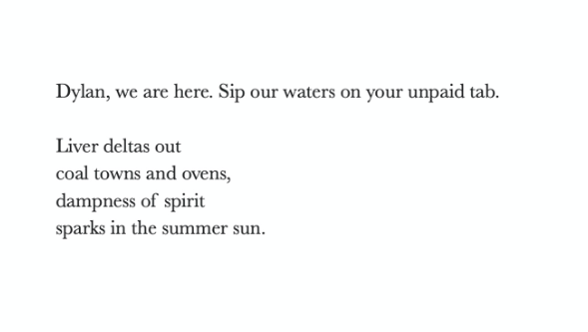
Much like a botanist in a scientific study, Kuppers follows the collection with her “field notes” indicating the“ empirical conditions” that produced the work, if you will. Of the painful imagery of Court Theatre,” Kuppers (2020) writes:
Healing from sexual assault by a body-worker is central to Gut Botany’s journey. I remediate lines from disabled dance artist Perel’s performance experiments and Bhanu Kapil’s interviews from The Vertical Interrogation of Strangers (2001). These seeds point outside of the cage of my memories to the frameworks of performance as wayfarer, embedment, community. (p. 86)
In this poem, we witness the performance of exhaustive labor required of so many survivors seeking justice. As Kuppers navigates legal and court systems, we are reminded that for people with disabilities, the demand to justify one’s right to exist as a sovereign body is unfairly augmented by widespread ableism, not only with the justice system, but in society at large.
Also included are collaborations with dancer/poet Stephanie Heit, visual artist Sharon Siskin, and deceased poet Dylan Thomas. In Poet Drag Kings,” Kuppers appears to be reveling in the pleasure of gnawing at the work of poets who populate the American cannon, crafting poetic intimacies which problematize their work in relationship to cultures of toxic masculinity. Addressing Thomas, Kuppers (2020) writes:
Dylan, you were the life of the party,
thirtynine dead in the Chelsea Hotel.
You beat your wife
that’s mainly what I remember.
Some lines of some poems.
Richard Burton’s voice.
We listen deeper
un-know colonial living on old-rock land.
I have survived you.
So has the woman I love,
most people I know.
Life in the forties. You missed out
on laughter lines, the longer duration
(p. 78)
Kuppers mentions time spent in Michigan with friend Margaret Noodin, the Anishinaabemowin poet and linguist, and the women of the Miskwaasining Nagamo- jig/Swamp Singers, as a primary source of inspiration for the volume. Likewise, reading the work through a lens of Indigenous survivance positions Gut Botany to offer a much-needed intersectional framework for connecting our understandings of material embodiment across Indigenous and Disability studies. These themes appear in Kuppers’s earlier creative research, such as collaborative dance and performance work with the Olimpias Disability Culture Collective. In Touching Disability Culture: Dancing Tiresias, Kuppers (2017) writes:
Disability approaches can learn much from concepts of survivance. Disability is not a cultural formation with narratives of homelands, spiritual connections, and genealogies. But disability is an historical process--one associated with the parsing and categorization of human knowledge in modernity. It is a complex of associations and ideas that merge together different people and makes them an ‘other.’ Disability and race share a history of devaluation based on a mixture of biological and cultural narratives: certain ways of being in the world are valued more than others, while others are seen as ‘less developed,’ ‘unfit for modern life,’ or ‘savage.’ (p. 608)
The influence of Indigenous epistemologies is deeply felt throughout Gut Botany, as Kuppers explores the ways in which settler cultures have constructed both Indigenous and Disabled identity both as biomedical and necropolitical realities. She boldly problematizes the ableism and heteropatriarchal domination of white settler normativity and its many fictions. We see this critique laid bare in “Big Spirit Moon”:“ I am not spared precarity/ in my occupation of indigenous lands/ I cannot see the lake the way you root/ drum, burn the chitin, an alarm” (Kuppers, 2020, p. 72). It is also evident in the final lines of “ Gut Body” on the very first page: primacy of white masculine fear/ close the leaky gut/ body drained of tears” (Kuppers, 2020, p. 1). Kuppers offers a vision of resistance, an unapologetic reckoning of her body’s history. It’s a story born of navigating through landscapes both hostile and fertile, a counter-narrative that queers all love, bodies, and relationships.
The experiences Gut Botany chronicles also seem to pay reverence to Indigenous frameworks of ethnographic refusal in its resistance to classification, interpretation, and traditional poetic form. For example, the final lines of “ Contours” are a set of single words and phrases spread almost randomly across the page. They appear as if soaring across a sky with a sweeping draw of birds flying overhead, or water cascading down a slippery rock waterfall. Throughout the collection, Kuppers’s work is animated by the performance of intimacies between human and more-than-human in a way that problematizes the anthropocentrism of naturalist poetry portraying the North American landscape. Instead, she presents to the reader a world where we recognize sovereignty as transspecies liberation.

Figure 3
Excerpt, “Contours”. From Gut Botany (p. 19), by Kuppers, P., 2020, Wayne State University. Copyright 2020 by Petra Kuppers.
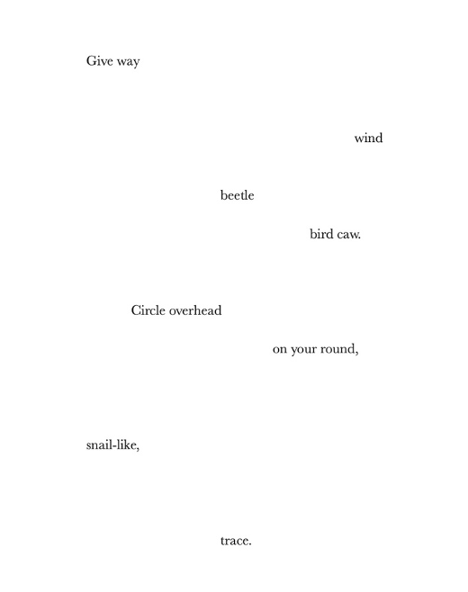
Gut Botany is a work that feels. It is a confrontational yet comforting examination of human vulnerability and is highly recommended reading not only for scholars in disability studies but also for those in Performance Studies, Queer Indigenous Studies, Gender and Sexuality Studies, Queer-Crip Theory, ecology, poetry, and American Literature. Much like Kuppers’s other works, the generosity of Gut Botany desires imitation. As it celebrates acts of communion between land, human, and more-than-human species which often go unnoticed, we find ourselves there, learning of deep reverence, devotion, and healing.

Maria Teresa Houar is a queer scholar of Indigenous Latinx, Mexican, Portuguese and Haole descent, born and raised in Hawaiʻi on the outer islands of Kauaʻi and Maui. Maria Teresa is a PhD candidate in Performance Studies at UH Mānoa researching dance performance through intersectional lenses of sexuality, fetish, queerness, disability, militarism, intimacy, and consent culture as a means of dismantling the colonized view of the body.

References
Kuppers, P. (2017). Touching disability culture. In V. Karkou, S. Oliver & S. Lycouris (Eds.) the Oxford handbook of dance and wellbeing. Oxford University Press. https://doi.org/10.1093/oxfordhb/9780199949298.013.33
Kuppers, P. (2020). Gut Botany. Wayne State University Press.
Review of Gut Botany by Petra Kuppers. Wayne State University Press (2020) by Maria Teresa Houar is licensed under a Creative Commons Attribution 4.0 International License. Based on a work at https://rdsjournal.org.

