Research Articles and Essays

Interview Survey on Provision of Assistive Technology Services for Students With Disabilities Under Covid-19 Pandemic

Takashi Watanabe¹, Hiroyuki Fujii ², Tomoko Hosho ³, Yuji Asaishi ⁴,

and Mamoru Iwabuchi ⁵

¹ Department of Human Care Engineering, Health Sciences, Nihon Fukushi University

² School of Social Work, Nagano University

³ Department of Social Welfare, Nihon Fukushi University,

⁴ Healthcare Management, Nihon Fukushi University

⁵ School of Human Services, Waseda University

Author Note
This work was supported by a research grant from Nihon Fukushi University.
Correspondence concerning this article should be addressed to Takashi Watanabe, Faculty of Health Sciences, Nihon Fukushi University, 26-2 Higashihaemi-cho, Handa, 4750012, Japan. wata-t@n-fukushi.ac.jp.
Abstract
Assistive technology services (ATSs) are essential for the provision, selection, acquisition, or use of accessible environments and assistive devices for students with disabilities. Additionally, ATSs require continuous support, as they include ongoing and dynamic processes. However, COVID-19-enforced “social distancing” has inhibited the crucial processes, despite the increasing needs for online learning environments and using ICT. To consider methods for ATSs to perform effectively and in a timely manner in the future, this study reports the results of an interview survey on how local facilities and special schools have implemented ATSs practices and resources during COVID-19 pandemic.
Semi-structured interviews were conducted at four regional assistive technology (AT) centers, two IT support centers for people with disabilities in communities, and five special schools in Japan. In all cases, remote AT consultations were conducted using videoconference software. Information obtained from the practices were categorized into seven items. The survey results suggest that hybrid ATSs benefit from remote access. Further studies are required to clarify the skills required by AT specialists in hybrid ATSs and to create training programs to learn remote equipment and visualization.
Keywords: Remote Assistive Technology Services; Multidisciplinary Collaboration; Supports for Students with Disabilities; Interprofessional Collaboration

Interview Survey On Provision Of Assistive Technology Services For Students With Disabilities Under Covid-19 Pandemic
Assistive technology services (ATSs) are essential for the provision, selection, acquisition, or use of assistive products for students with disabilities as well as accessible environmental arrangements (e.g., assistive devices and software, accessibility features of operating systems, and equipment for posture optimization) (S.2401-117th Congress, 2021-2022). ATSs must be conducted based on a process that initiates assessments that consider individual needs, as well as physical, psychological, and social factors. Federici et al. (2012) introduced an Assistive Technology (AT) assessment process flowchart as a basic process for ATSs. It indicates that clinical measures, functional analyses, and psycho-socio-environmental evaluations are essential assessment items in the initial step of ATSs. Next, assistive solutions are provided through user trials and evaluations by ATSs supporters in a multidisciplinary team. After providing the assistive solution, supporters involved in ATSs must monitor the client for short- or long-term use from the perspective of personal well-being, user satisfaction, and benefits from use. Then, depending on user needs and the monitoring situation, user support and follow-up are conducted by the ATSs supporters. ATSs are an ongoing and dynamic processes (CIDE, n.d.). The flow is not one-way, and often reverts to the previous step in response to the evaluation of each step. In other words, even after providing accessible environmental arrangements and assistive products, the steps of reassessment, readjustment, and reselection of ATSs are required depending on the individual needs of AT users.
Based on these models, Watanabe et al. (2022) proposed a typical process flow of ATSs consisting of seven steps (Figure 1): “assessment,” “assistive technology (AT) proposal,” “AT user-trial,” “tailoring AT to the user,” “AT provision,” “user support,” and “follow up.” However, COVID-19-enforced “social distancing” has inhibited the crucial ATSs processes despite the increasing needs for online learning environments and ICT. Local communities and facilities have adopted various methods, such as remote ATSs, to address this problem (Easterseals, n.d.). In DO-IT, Japan’s 2020 summer program (DO-IT Japan, n.d.), remote ATSs were conducted using online meeting software for two students with physical disabilities (Watanabe & Matsukiyo, 2021a; Watanabe, Matukiyo & Okuyama, 2021b). This study considered methods to ensure that the process of ATSs can perform effectively and in a timely manner by reporting the results of an interview survey on how local facilities have conducted ATSs with practice and resources.
Figure 1
Typical process flow for assistive technology service (ATS)
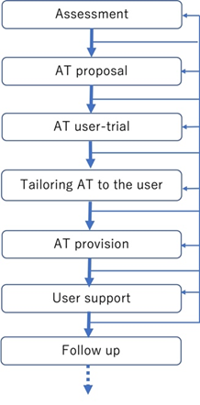
Image Description: The image represents a typical process flow of assistive technology service (ATS). This flow consists of seven steps: assessment, assistive technology (AT) proposal, AT user-trial, tailoring AT to the user, AT provision, user support, and follow-up.
Methods
This interview survey was conducted in facilities that provided continuous ATSs and special schools that implemented remote ATSs using an online meeting system with AT specialists in situations where social distancing had to be maintained to prevent COVID-19 infection. The interviewees were the people who have performed ATSs. The survey participants were directly involved in these ATSs. After obtaining consent to participate in the survey, semi-structured interviews were conducted at each facility and school to which the subjects belonged.
The questions for facilities providing ATSs were as follows:
- How did you continue your regular ATSs in situations where you had to maintain social distancing to prevent COVID-19 infection?
- When you could not provide ATSs in a regular manner, what kind of ways did you alternatively choose?
- What was the case like if an alternative method was not feasible?
- Regardless of the need for maintaining social distancing or not, what kind of systems or tools are necessary to continue ATSs in the future?
The questions for the special schools implementing remote ATSs using an online meeting system were as follows:
- When implementing remote ATSs, what kind of environmental improvements have you organized, including human resources and equipment?
- What are the advantages and disadvantages of remote ATSs compared with regular face-to-face ATSs?
- What cases could not be treated with the remote ATSs? What are ways to compensate for this?
- Regardless of whether face-to-face or remote ATSs are used, what kind of systems or tools do you think useful in the future?
The interviews were conducted by two or three of the authors at four regional AT centers, two IT support centers for people with disabilities in communities, and five special schools in Japan. There were 36 participants: 19 teachers, 5 occupational therapists, 3 physical therapists, 3 AT specialists, 2 medical doctors, 2 social workers, 1 caregiver, and 1 rehabilitation engineer. Written informed consent to participate in this survey was obtained from all participants. To avoid burdening the participants, each interview was limited to 60 minutes; if it was likely to exceed 60 minutes or the participants requested for it, consideration was given to either taking a sufficient break or conducting the interview on another day. Interviews were conducted in person at the facilities or schools to which the participants belonged. However, to prevent COVID-19 transmission, interviews were conducted using an online meeting system, depending on the circumstances or the participant's request. Each interview was recorded with audio and video to ensure the accuracy of the interview content. This study was approved by the Ethics Committee for Research on Human Subjects at the Nihon Fukushi University (approval number: 21-017-1).
Results
In all cases, remote AT consultations have been conducted using video conference software to maintain social distancing during COVID-19 pandemic. The clients have been accessed remotely. As for examples of “Alternative means for continuing regular ATSs,” the surveyed AT centers and the IT support centers provided online contents, such as hands-on webinars (Nagoya Assistive Technology Center, n.d.) and AT user reviews (Okinawa IT Support Center, n.d.).
Regarding the “Advantages and disadvantages of remote ATSs in AT consultation,” interviewees described the differences between face-to-face ATSs and remote ATSs in the case of special schools. When conducting face-to-face ATSs, AT specialists attend special schools and provide ATSs to clients, who are AT users, their teachers, and the families (Figure 2). AT specialists include rehabilitation engineers, physical and occupational therapists, social workers, etc., who are familiar with AT. When providing ATSs, these AT specialists convincingly communicate while demonstrating the assistive devices in person and conduct trials with their clients. They also attempt to provide useful feedback that their clients have not noticed. They valued comfortable relationships and interactive information sharing with their clients to provide better ATSs.
Figure 3 illustrates a remote ATS situation. AT specialists remotely access on-site AT users and their teachers using video conference software (e.g., Zoom). Remote ATSs require several teachers to assume multiple roles, including camera operator, network support, and general teacher roles. AT specialists cannot step back and observe the AT users (i.e., clients) as they would in person. In other words, remote ATSs must consider solutions based only on visual or verbalized information. For example, in the case of individuals with physical disabilities, AT specialists need to assess body functions by touching the client to examine the degree of muscle power, muscle tone, trunk balance, condition of involuntary movement, etc. However, this information cannot be gathered through remote access. Even though the range of joint motion and active movement of clients can be observed, it is also difficult to understand active assistive or passive movement through a screen.
The interview survey showed that while remote access has its advantages, tools and techniques to share non-verbal information and measure visually unrecognizable movements of AT users through a screen are necessary.

Responses to the interview survey were categorized as follows:
- Development of an online network and procurement of related equipment
- Skill set of the on-site supporters with the AT users (i.e., the client)
- Skill set of the remote advisers
- Effective means of remote communication
- Advantages and disadvantages of remote ATSs
- Loss of users’ opportunities to try out AT
- Alternative means for on-site ATSs
Figure 2
Face-to-face ATS situation in the case of a special school
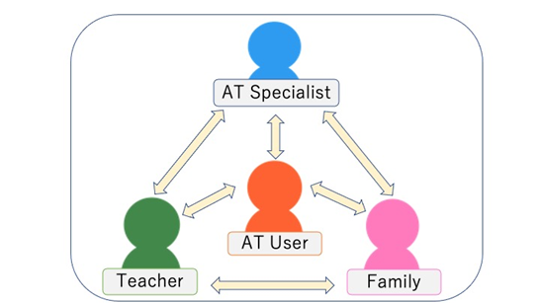
Image Description: Image represents a face-to-face ATS situation in the case of special schools: An AT specialist, an AT user, their teacher, and their family communicate with each other on-site.

Figure 3
Remote ATS situation in the case of a special school
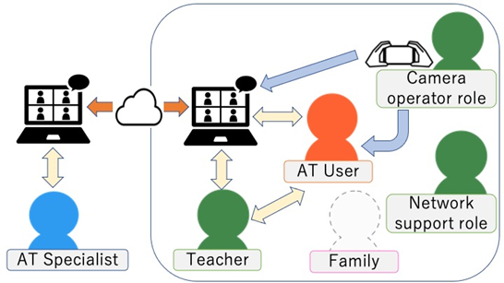
Image Description: Image represents a remote ATS situation in the case of a special school: An AT user, their teacher, and their family are on-site, and an AT specialist accesses them using online conferencing software. They communicate with each other through the screen.
Discussion
In this interview survey, it was found that it is difficult to comprehensively assess the physical functions of people with severe motor and intellectual disabilities using remote ATSs. In addition, it is difficult to obtain a sense of the atmosphere or situation in the remote ATSs. This is because the remote advisers struggle to find solutions based on visually unrecognizable movements, simple gestures, and non-verbal cues through the screen.
To address these problems, ideas for bridging the on-site gaps in the remote ATSs based on the categorized items in the Results section are considered. Regarding “Skill set of the on-site supporters with the AT user,” the following roles are required:
- Clear descriptions to share conditions of AT users on-site with remote AT specialists
- Interpretation of advice from remote AT specialists for AT users and their supporters on-site
Useful technology for “The development of an online network and procurement of related equipment” and “Effective means of remote communication” could be listed below:
- Remotely controllable camera for AT specialists
- 360-degree camera to see the surroundings of AT users on-site
- Application of motion capture technology
Hence, remote advisers (AT specialists) are expected to provide helpful advice to the on-site supporters and AT users using these technologies effectively as “Skill set of the remote advisers.”
Although there were no cases of people with developmental disabilities this time, but in the interview step of the ATSs process, using remote access might be useful for them as an “Alternative means for on-site ATSs.” One benefit for them is that they can maintain comfortable distances from each other. In addition, clients can communicate by turning off the screen and using only voice or text chat only.
However, it is not always better to replace face-to-face ATSs with remote ATSs for the sake of efficiency or cost performance. As described in the Results section, remote ATSs could lead to the loss of users’ opportunities to try out AT. This means missing out on increased self-awareness for considering their future life. Moreover, ATSs often depend on the empirical knowledge and experience-based skills of an individual or regional community, especially when methods of production or remodeling assistive devices are applied (Watanabe, Hatakeyama & Tomiita, 2015). Owing to this reliance on individuals and the regional gaps in social resources, education, and welfare services, the quality of ATSs would have been influenced.
Therefore, we propose a hybrid ATS that combines the advantages of face-to-face and remote ATS, as shown in Figure 4. This would allow various helpful resources to be accessed on-site while simultaneously conducting ATSs, regardless of distance. AT specialists and supporters conducting ATSs for their clients on-site can ask for advice from AT experts and access social resources regardless of distance using remote access. This hybrid method can help to enhance the quality of ATSs. In the hybrid ATSs, on-site AT specialists are required not only to verbally describe the circumstances but also to interact with the AT user while sharing the understandings and the intentions of remote AT specialists. On-site supporters, including network supporters, may require knowledge and techniques to operate new equipment, as described previously. Therefore, creating a training program to teach these skills is a topic for future research.
Figure 4
Image of hybrid ATSs
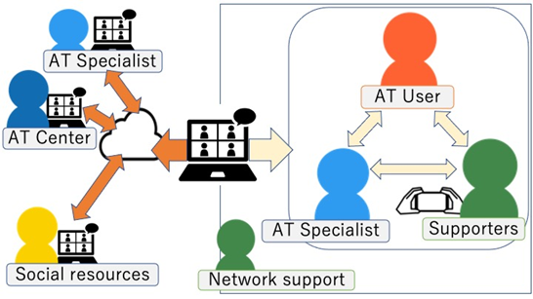
Image Description: Image represents a hybrid ATS situation in the case of a special school: An AT user, their teacher, their family, and an AT specialist are on-site. Another AT specialist, advisers belonging to an AT center, staff of social resources services, etc., access them using online conferencing software. They communicate with each other through the screen.

Conclusion
The interview survey categorized the information obtained from remote ATSs practices into seven items. The survey results suggest that it is more important to develop methods that take advantage of remote access, tools, and techniques to share non-verbal information and visually unrecognizable movements of clients with disabilities through a screen than to pursue face-to-face consultations at every step of the ATS process. This led us to propose the hybrid ATSs. Further studies are needed to clarify the required skills for the remote AT specialist and the on-site AT specialist on the hybrid ATSs and to create a training program to learn remote equipment and visualization while analyzing the transcriptions of the interviews in detail, although this study provided useful insights for improved ATS provision in the future.
ATSs using remote technology have also attracted attention as “TeleAT” by the World Health Organization (WHO, 2022), and practical research areas should be increasingly addressed. We hope to propose collaborative ATSs through further surveys and practical outreach activities using the hybrid ATSs.

References
Center for Inclusive Design & Engineering (CIDE). (n.d.). Assistive Technology Assessment.
http://www.swaaac.org/assistive-technology-assessment
DO-IT Japan. (n.d.). Report and video DO-IT Japan. https://doit-japan.org/report-video/
Easterseals Massachusetts- Remote Assistive Technology services (n.d.).
https://massachusetts.easterseals.com/get-support/areas-of-support/assistive-
technology
Federici, S., & Scherer, M. (Eds.). (2012). Assistive technology assessment handbook.
CRC Press.
Nagoya Assistive Technology Center. (n.d.). https://www.youtube.com/channel/UCXR4qQLA6eVr3UVsUhJK5zQ/featured
Okinawa IT Support Center. (n.d.). Okinawa IT Support Center Official Channel. https://www.youtube.com/channel/UCw1cwkhP2YzDhqgsLZ3kxBA
S.2401-117th Congress (2021-2022). 21st Century Assistive Technology Act. https://www.congress.gov/bill/117th-congress/senate-bill/2401
Watanabe, T., Hatakeyama, T., & Tomiita, M. (2015). Improving assistive technology service by using 3D printing: Three case studies. Assistive Technology Building Bridges, 217, 1047-1052.
Watanabe, T., & Matsukiyo, A., (2021a). A Case Study in Arranging Accessible Environments for Students with Disabilities. 36th Annual Pacific Rim International Conference on Disability and Diversity, Honolulu, HI.
Watanabe, T., Matsukiyo, A., and Okuyama, T., (2021b). Possibility of Assistive Technology Service by Remote Access - Conducting of Technology Fitting Session in DO-IT Japan Project -. Rehabilitation Engineering, 36(2), 122-127. https://doi.org/10.24691/resja.36.2_122
Watanabe, T., Iwabuchi, M., Hosyo, T., Asaishi, Y., Fujii, H., (2022). Trial Production
of an Interactive Assessment Tool “AT Chatbot” for Continuing Assistive
Technology Services. Human Interface Symposium 2022, 334-337.
World Health Organization (WHO). (2022). Global report in assistive technology.
https://www.who.int/publications/i/item/9789240049451

Interview Survey on Provision of Assistive Technology Services for Students With Disabilities Under Covid-19 Pandemic by Watanabe et al. https://rdsjournal.org/index.php/journal/article/view/1169 is licensed under a Creative Commons Attribution 4.0 International License based on a work at https://rdsjournal.org.

