Deaf Community and DiDRR: Supporting a Twin-Track Approach
Leyla Craig¹, Audrey Cooper², Kota Takayama², and Herbert Klein³
¹ University of Sydney
² Gallaudet University
³ World Federation of the Deaf, Disaster Risk Reduction Expert Group

Abstract
To address Deaf Communities that are continually excluded from Disability inclusive Disaster Risk Reduction (DiDRR), community-based research and practices have found that adopting a twin track approach tailored to each deaf group and its specific communication practices are more effective than combining disaster training for all disability groups.
Keywords: Deaf communities, disasters, communication

Background: DiDRR
A definition of language is always, implicitly or explicitly, a definition of human beings in the world. - British Cultural Studies Scholar, Raymond Williams, 1977:21
The concept of Disability inclusive Disaster Risk Reduction (DiDRR) was established to support and ensure that people with disabilities are included in all emergency and disaster management planning. This idea has garnered support from many countries where this initiative brings people with disabilities, government, and non-government organizations together to heighten their DRR (Disaster Risk Reduction) and DiDRR knowledge, skills, and practices. With cases of DiDRR projects and training workshops designed to increase people with disabilities’ resilience to natural hazards and disasters, some countries erroneously perceive people with disabilities as ‘one homogenous group’ by combining disaster training for all disability groups. This is problematic given that what sets Deaf Communities apart from disability groups is the language and culture.

Deaf Community: Disability and Linguistic Groups
According to the World Federation of the Deaf (WFD), an international non-governmental organization that advocates for the human rights of more than 70 million deaf people in the world, Deaf Communities are in a unique position with respect to disability given their shared experiences of societal barriers and oppression and aims for equality rights and access (Burch & Kafer, 2010). The common goal of making society accessible and inclusive to people of different abilities is what brings the Deaf Community together with the international disability movement (WFD, 2019). However, from a cultural perspective, language is also seen as an important aspect to linguistic minority communities that identifies the Deaf Community as group and cultural identity. As disabled people often identify and use the dominant language(s) of their country of origin, Deaf Communities’ primary languages are sign languages, known to be non-dominant and a fundamental element of Deaf Culture (Lane, 1992). The cultural language differences and lack of equity with communication divides the experiences and stances between Deaf Communities and other disability groups (Padden & Humphries, 1988, 2005; WFD, 2019); this is why Deaf Communities justify recognizing themselves as a cultural and linguistic group under the United Nations Convention for the Rights of Persons with Disabilities (UNCRPD). Furthermore, the intersectionality of deaf, disability, and linguistic groups together has multiple dimensions and considerable demographic intersectional features, including race, gender, sexuality, heritage cultures, ethnicities, and so forth; this includes in connection to multimodal uses of the body and languages (De Meulder et al., 2019; Harrelson, 2019). With the diverse deaf population involving deaf, culturally Deaf, hard of hearing, and deaf-plus; there are also further aspects pertaining to racism, sexism, audism, ableism, ageism, religion discrimination, as well as cultural and language practices related to their affiliation with local Deaf Communities too.

Deaf Communities and Language Access
As one of the few research studies that offers disaggregated data demonstrating the percentage of people affected from different disability groups, Takayama (2017) reveals that deaf people experienced higher rates of mortality and morbidity during and after the 2011 Japanese earthquake and tsunami, citing 0.76% of the deaf population compared to 0.17% of the hearing population (Takayama, 2017). The issue here is deaf people being more impacted not because they are deaf, but because they have almost no access to disaster preparedness and protection resources. There are multiple reasons for this, starting with language.
Language is a critical part of the human experience. According to the WFD, only 20% of deaf people around the world have access to formal education. Furthermore, only 21.2% of countries around the world recognize their national sign language. This has led many Deaf Community members facing communication barriers due to inaccessible information (Calgaro et al., 2021; Cooper et al., 2021; Cripps et al., 2016; Engelman et al., 2013; Takayama, 2017). This has posed challenges for disaster management as to whether their disaster messaging, especially on the language use, is readily understood by deaf people. Lack of proper access to emergency information and services further heightens Deaf Communities’ risks to disasters. This is an ongoing problem where some barriers are firmly embedded in DRR policies and practices.

Deaf and DiDRR
To achieve DiDRR requires a fundamental shift in DRR strategy and practice that is central to people with disabilities. Those best placed to demonstrate DiDRR successes involve challenging the stigmatizing perceptions of people with disabilities and convince DRR actors and governments to fundamentally change the way they approach DRR that enables people with disabilities opportunities to fully participate and learn by doing alongside their DRR counterparts. This will enable people with disabilities trained to work in the DiDRR space, which will in turn help expand networks to support future professionals and practitioners with disabilities in this field. The concept itself is very progressive yet the implementation and practices remain questionable, particularly for Deaf Communities who continue to remain underserved in DiDRR.
Given that language and cultural practices is what brings Deaf Communities together, this is also what sets them apart from other disability groups in DiDRR. In the disaster context, communication is seen as the biggest language barrier for Deaf Communities stemming from the lack of qualified sign language interpreters, provision of sign language interpreters, and inaccessible disaster information in plain language, visual pictures, and/or in sign language. Research suggests deaf people are particularly vulnerable to increasing risks due to inaccessible emergency information, and efforts to support them in these capacities continue to fall short of their needs (Cooper et al., 2021; Engelman et al., 2013; Takayama, 2017).
As mentioned earlier, some DiDRR approaches erroneously perceive people with disabilities as one homogenous group where one training is provided for all. This has proven to be ineffective as the outcomes have made little impact on Deaf Communities’ ability to learn and increase their resilience to natural hazards and disasters. There are DiDRR training offered for deaf people to join, but the training itself is often provided and designed by and to fit people who are hearing. Most of the training workshops are heavily auditory based, which has placed challenges for deaf people to follow discussions and activities. This hinders deaf people from advancing on the same playing field with other disability groups, highlighting several underlying issues starting with “access” versus “inclusion.” Just because there are interpreters provided in the training does not guarantee the inclusiveness of deaf people. There are also two potential layers of challenges in addition for deaf people using sign language interpreters in DiDRR training workshops: (1) having interpreters selected by hearing non-signers who may not know the difference in competencies of interpreters; or (2) having an interpreter with limited knowledge or understanding of the DRR context. The competencies and DRR knowledge that the interpreter has determines whether the information delivered will be accessible for deaf people to understand and whether the training process will be inclusive.
Furthermore, exclusionary communication and language practices were also found in the access planning process as well (Calgaro et al., 2021; Calgaro & Dominey-Howes, 2013; Cooper et al., 2021; Craig et al., 2019; Craig, 2017; Engelman et al., 2013; Takayama, 2017). The needs of deaf people are also often given little to no attention in DRR policies and regulations (Ivey et al., 2014). Moreover, emergency preparedness training designed for deaf people are unheard or unaccounted for, along with the lack of standardization, evaluation, or mainstreaming in disaster management infrastructure and practice (Engelman et al., 2013).

Twin Track Approach
To achieve and sustain mainstreaming DiDRR approaches and practices, the training needs to be central to the targeted audience and its cultural, language, and/or access practices. One training for all disability groups does not work as there is no such thing as a “one size that fits for all.” On the contrary, the “twin track” approach proposes tailoring training to a group and its specific practices. For this case, a Deaf DiDRR training is needed to accommodate each deaf group (deaf, deafblind, hard of hearing, deaf-plus) and each group’s communication and language practices. When a DiDRR training is tailored to a deaf group, this enables deaf people to maximize their abilities to acquire the knowledge and skills delivered in their native language. Once they master the training, they can then become sustainable agents of change by serving as a bridge to future DRR training and participate in broader DiDRR activities.
Drawing case studies from four different countries, three stages were identified in recognizing a DiDRR training for their local Deaf Communities. The first stage is identifying a needs assessment through conducting community research. This will assist in recognizing the gaps and what type of training is needed to support Deaf Communities in the DRR space. The second stage is where the action happens. Deaf Community leaders with their sign language interpreters identify emergency service agencies who can train deaf people in becoming DRR trainer-apprentices. This part is key to creating sustainable key agents of change as the training will give deaf people the knowledge and skills for preparing, responding, and recovering from DRR. Once Deaf Community leaders have mastered the DRR training sessions, they will be well placed to conduct a fully deaf-led Training-of-Trainers (ToT) on their own with their local communities (see Figure 1 below).
Figure 1
Stages for DiDRR Twin Track Approach
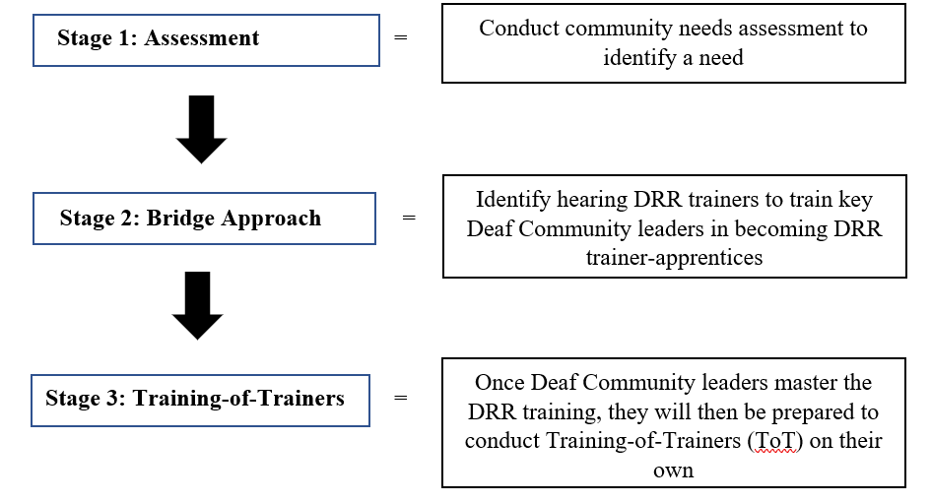

The four case studies –Indonesia, Vietnam, Australia, and Japan, all have conducted a project that focuses on or related to DRR through one of the three stages. Indonesia and Vietnam are currently at Stage 1 where a needs assessment has been conducted and the recognition for DRR training is needed. Australia has already conducted a needs assessment on Deaf Communities in the state of New South Wales (NSW) and has moved forward towards Stage 2 where deaf people were trained by the state’s emergency service agencies. Japan, which has had its fair share of disasters in the last decade, has surpassed Stage 1 and Stage 2 where community needs and training by its emergency services has been conducted. Japan is now in the advanced stage where it may offer deaf-led ToT on DRR to Deaf Communities throughout Japan. Further details on each case studies are highlighted below based on their current stages.

Case Studies Stage 1: Assessment

Indonesia: Assessment by Deaf Organizations and Collaborating Partners
Indonesia is one of the disaster-prone countries in the world. With 17,000 islands, the country has the fourth largest population in the world with 280 million people from five different religion groups where 85% are practicing Muslims. Within that population, there are roughly 40 million who are deaf non-signers, hard of hearing, and late deafened, where 4 million of them use Bahasa Isyarat Indonesia (BISINDO) Sign Language (Palfreyman, 2019) to communicate (Statistics Indonesia, 2015).
Deaf Communities who use BISINDO experience multiple barriers in Indonesia, one of them involving mental health services. This is critical because the country is home to numerous disasters per year, which can be traumatizing for many deaf people if they have no access to information and services. There is a Deaf organization called Gerkatin (Indonesian Deaf Association) with 30 branches and 50 BISINDO interpreters throughout the country, yet they are under-resourced and have limited capacity in responding and supporting those affected. The challenges are greater for those in remote or isolated areas.
In 2015, Indonesia passed a new law, the Mental Health Act, based on the significant impacts the 2004 tsunami and earthquake in Aceh had on local people and their communities. Before the law, mental health services were delivered in institutions that were overcrowded and in terrible and unsanitary conditions. There were people in “pasung” shackled cages or chained to the wall and wooden stocks tied up for many years. The new law was implemented to change the system, employing approximately 1000 psychiatrists to serve the entire country. Out of 34 provinces, 27 of them implemented the new law while the remaining could not be due to cultural barriers on tribal islands.
As a retired Deaf Mental Health Advisor, Herbert Klein collaborated with Laura Lesmana Wijaya, Head of the Sign Language Center in Indonesia, on conducting community-based research in 10 different places in Indonesia on mental health awareness for Deaf Communities. Undertaking this research involved three different sign languages translated to communicate with local Deaf Communities: (1) Klein, as a foreigner, used International Sign Language; (2) Wijaya used International Sign Language and BISINDO; and (3) the last was a local person from each place who understood BISINDO and the local sign language used on that respective island. The research consisted of a set of questionnaires where each question was processed through a PowerPoint presentation and delivered in the following communication methods: role playing, gesturing, facial expressions, visual pictures, simple language, and video clips. It was important to document every participant’s response through any of the methods to meet the varying communication needs of each deaf participant before moving on to the next question.
200 deaf people participated in the questionnaires where results showed that 90% of them exhibited signs of depression and anxiety with three notable case studies that emerged from this research that revealed insufficient mental health support, information and advice provided by local services for deaf people:

Case A: A deaf woman with schizophrenia was unable to communicate and stayed home most of the time. As a result, she was often ignored by her family because they believed she could not communicate but after Wijaya and Klein interacted with her, she responded very well after being asked to perform certain tasks (i.e., picking up a cup, pouring water, etc.). She was also able to maintain eye contact through sign language. The mother showed the medication her daughter was on and lacked understanding of what condition her daughter had and the treatment (Haloperidol, Risperidone) she was taking.

Case B: A deaf man with schizophrenia often wandered the streets, exhibited violence and begged for food. He talked to himself via sign language and shouted at people often. It was difficult to communicate or maintain eye contact with him. His parents showed the medication he was on (Clozapine) but they were unaware of what it was for other than what his local doctor labelled as: ‘Deaf and mute’.

Case C: A deaf woman came stating that she had suffered abuse from her husband. Her arm was bruised, and she felt she could not ask for help because the local social services assumed that Deaf Community members do not experience any abuse and that there is a lack of shelters for domestic violence catered to the needs of deaf women. When this was addressed again with social service, they advised to ask the Deaf Centre. The problem with the Deaf Centre is that they lack the qualifications needed to support deaf women in domestic violence situations, and the head of the Deaf Centre was, in fact, the abuser in this case.
Given this was the first time a research study had been conducted in Indonesia, it was successful because of language access through the use of local BISINDO and Deaf Relay interpreters to translate sign languages tailored to suit local deaf people. It was critical that language access and communication needs be factored in for any activities involving Deaf Communities and notably, for future disasters as well.
The data thus collected was used to consult with the government’s Department of Health team, universities, and Ibundi (Indonesian Psychology Association) to heighten the awareness on Deaf Communities and their mental health needs, including applying this for future disaster events. It is hoped that this will help push for a change to the mental health system for Deaf communities. Future planning in the works includes:

- Establishing Deaf Mental Health Training for clinical professionals on understanding different communication needs and cultural differences within the Deaf Community as that could potentially impact diagnosis and treatment plans;

- Conducting further research projects to improve Deaf Communities and their access to social, mental and physical health, with particular attention around disasters,
- Increasing communication support in the form of both hearing and deaf sign language interpreters to accommodate the varying communication needs of deaf people,

- Providing more Deaf Mental Health Training for the Deaf Indonesian Community on understanding and recognizing mental health issues in oneself and others as well as empowering them to establish better mental health mechanisms in their communities.

Vietnam: Deaf-Led Organizations Assessment and DRR Action
Global indexes rank Vietnam among the top ten countries impacted by extreme weather events and natural disasters, with a 3260 km coastline, 15 major islands and thousands of islets (2020 Global Climate Change Risk Index; cf. 40/191, 2019 World Risk Report). The 2021 Vietnam Disaster Management Reference Handbook further underlines that the country is one of the most “hazard-prone countries in the Asia-Pacific region" due to a high risk of flooding, landslides, and coastal erosion related to extreme storms, tropical cyclones, typhoons, and monsoon. Vietnam also has a disproportionately high disability prevalence, particularly in areas impacted by the toxic defoliant Agent Orange used by the United States military during the American-Vietnam war (Le, Pham, & Polachek 2021). The 2016 Vietnamese National Survey on People with Disabilities reports that 7.06% of the population, or 1 out of every five households, has a family member with a disability; of these, about 1.3 million people are deaf or hard of hearing (GSO 2016).
Research conducted in 2019 on deaf-led organizations and disasters in Vietnam identified that deaf people are overwhelmingly impacted by disaster and extreme weather events, and overwhelmingly excluded from Disaster Risk Reduction (DRR) activities in the country, including public information and communication of extreme weather forecasting, emergency alerts, and disaster events (Cooper et al., 2021). Conducted by one US-based researcher (co-author of this conference paper) and six researchers associated with deaf organizations in North, Central, and South Vietnam: Hà Nội (northern, metropolis), Huế (central, flood plains), Đà Nẵng (central, coastal), Hồ Chí Minh City (southern, metropolis), Tiền Giang (southern, Mekong Delta), and Cần Thơ (southern, Mekong Delta). Study methods included interviews with 28 deaf organizations leaders, group surveys with 83 deaf organization members, auto-illustrations and photography of disaster events, and participant observation in all six sites. According to the six deaf organization leaders who collaborated on the 2019 research, deaf people’s involvement in DRR activities began in 2011–2012 when an INGO-supported Disability-Led Organization in Vietnam invited deaf organization leaders to join DRR training. Deaf organizations also began posting disaster-related content in social media posts at this time.
Deaf community leaders reported that they initially saw their participation in DRR training activities as promising, with efforts made by several disability-led organizations to provide interpretation for deaf and hearing participants in DRR training. However, only a very small number of deaf community members were invited to participate (under 10), six of whom participated in the 2019 research project and who reflected that the training had many barriers to accessing vital DRR content, due to the following constraints: “training designed for hearing people and delivered in spoken Vietnamese; interactions mediated by Vietnamese Sign Language(s)-Vietnamese interpreters, with hearing participants talking quickly or at the same time preventing interpreters from capturing the content; presenters privileging interactions with other hearing people; and, lack of training content specifically addressing DRR with deaf communities” (Cooper, et al 2021: 10). In addition to these constraints, research participants reported that their access to public sources of disaster information and communication was nearly nonexistent: 100% (28/28) of interviewees and 91.5% (76/83) of survey participants reported that they received no information from broadcast media or government sources (Cooper et al., 2021: 8).
As there are no formal interpreter training programs in the country (though several are in development), a national association would also provide a platform for mobilizing and advocating for advanced sign language training and interpreter training. Sign language interpretation in trainings and televised broadcasts (two 30-minute daily news broadcasts, one from Hà Nội and one from Hồ Chí Minh City) might be perceived as a solution to deaf community participation and leadership in DRR activities; however, televised content is disaster-specific. Moreover, there is an extreme human capital shortage where interpreters are concerned, as Vietnam does not have formal signed-spoken language interpreter training programs, nor systems for assessment and credentialing, so all services are delivered through largely self- and community-taught intermediaries who are also self-governed. Given these circumstances, data on deaf community use of televised news broadcasts is understandable: 100% of deaf leaders interviewed and group survey participants reported that they were aware of interpreted news broadcasts; however, no (0) interviewees and only 8.43% (7/83) of survey participants reported watching the interpreted news. The reasons that participants gave for not viewing the broadcast news centered on the kind and quality of the sign language interpretation and on the lack of closed captioning (Cooper, et al., 2021: 8). It is in the context of these multi-layered circumstances, that deaf community leaders began mobilizing to develop their own disaster information. Unsurprisingly, the majority of research participants reported that they rely on deaf community sources and networks for disaster/emergency information, especially communication in sign language by deaf community members via Facebook as a main source of information, as well as videos received from deaf community members through Zalo (video messaging platform) (Cooper, et al., 2021: 8).
The above research data make clear that, particularly with present constraints on the production and circulation of disaster information in signed languages in Vietnam, deaf people face routine marginalization, even in settings where interpreters are provided for DRR training. The immediate solution posed to this situation by deaf community leaders is that DRR training should be provided by deaf people in sign language “to ensure access to information and applicability of the content to deaf communities in Vietnam,” but until such time as “deaf people have developed DRR training capacity, hearing trainers-of-the-trainers might be needed to bridge training expertise” (Cooper, et al 2021: 10). Deaf community leaders further recommended that such bridge training involve a minimum of hearing lead-trainers or other hearing participants, in order to maximize the deaf-cultural and linguistic shaping of DRR training approaches, and deaf self-determination in the training setting.

Case Study Stage 2: Bridge Approach

Australia: Piloting Training-the-Trainers Bridge Approach
The state of NSW, Australia is prone to multiple hazards, yet emergency warnings and messaging continues to be inaccessible for deaf people to gain information on how to best prepare, respond, and recover from emergency and disaster events. To address this oversight, the University of NSW (UNSW) partnered with the Deaf Society of NSW, Fire and Rescue NSW (FRNSW), NSW Rural Fire Services (RFS), and the State Emergency Services (SES) on a two-year project entitled Increasing the resilience of the Deaf Community in NSW to natural hazards and disasters (Calgaro & Dominey-Howes, 2013) as part of the Stage 1: Assessment. It aimed: (1) to increase the resilience of Deaf Community to future natural hazards and disasters through improved access to and provision of emergency management information; and (2) maximize resources, knowledge, and skills between emergency service agencies and Deaf Communities on disaster and hazards and Deaf Awareness.
The project concluded with a series of recommendations designed to: (i) increase deaf people’s accessibility to and provisions of emergency management information and programs; (ii) strengthen social capital within communities and build stronger institutional linkages; (iii) increase the capacity of NSW emergency service organizations to better support the Deaf Community in hazard situations and meet their identified needs; and (iv) facilitate greater Deaf Community engagement in and shared action on disaster and emergency preparedness (Calgaro and Dominey-Howes, 2013). These recommendations resulted in two ‘big wins’. First, Australian Sign Language (Auslan) interpreters were provided on TV emergency live news for the first time in NSW during the Blue Mountains 2013 Bushfire. Having Auslan interpreters included in live emergency broadcasts was a major communication breakthrough, enabling the NSW Deaf Community to gain crucial access to emergency information and news in their own language.
The second win of this project was a critical aspect of Stage 2 where a follow-up project in 2016 entitled Get Ready Deaf Community NSW achieved implementing one of the key recommendations of work - the training pilot of Deaf Liaison Officers (DLOs) (Roberts, 2018) through a twin-track approach. DLOs are deaf volunteers who bridge information and skill sharing between Deaf Communities and emergency services. Through this project, up to 14 DLOs fluent in both Auslan and English from six regions across NSW, received training from the Office of Emergency Management, NSW RFS, NSW SES, Fire and Rescue NSW, Australian Red Cross, and The Deaf Society in the following capacities: basic emergency management; emergency preparedness; leadership; community development; workshop delivery and mentoring. As gatekeepers to the Deaf Community, DLOs also provided emergency preparedness information and workshops for deaf people through Deaf Communities’ networks; Deaf Awareness Training for emergency services staff (benefitting 351 staff); advised emergency services on accessibility and cultural appropriateness of resources, and promoted campaigns and services delivered by emergency services organizations.
Since its implementation, post-project interviews were conducted in 2020 and onwards with 8 DLOs and 5 representatives from emergency services on the successes and shortcomings of this project. Among what was achieved includes heightened the awareness within emergency services on the diversity of Deaf Community members and the different communication approaches involved; generated deaf peoples’ interest in becoming involved with their local emergency services and changed their views on being expected to be assisted by emergency services to taking responsibility of their own emergency preparations and response. However, this was not without limitations as well. There were three main shortcomings to this project that involved the need to develop a training curriculum tailored for deaf people as the one provided through the project was catered for and by hearing people. Secondly, the majority of the project focused more on the provision of the training and community workshops and little attention towards strengthening team capacity building. As a result, the quantity was valued more than the quality of how the training and workshops were delivered. Lastly, there was internal support from the emergency services’ ends; however, red tapes of getting funding hindered the continuation of this project.

Case Study Stage 3: Bridge and Twin-Track Approaches

Japan: Sustaining Deaf-Led Training-the-Trainers
Historically, Japan has a large population that has been affected by earthquakes and other disasters with the ratio of disaster mortality increasing (Nakabayashi, 2012). In March 2011, Japan experienced a giant earthquake and tsunami that claimed the lives of approximately 15,000 people. According to a survey related to the Tohoku earthquake (Fujii, 2015), the mortality rate of people with disabilities was more than twice as high compared to people without disabilities. In the Tohoku earthquake alone, 75 deaf people died from the combination of powerful earthquakes and tsunami waves (Takayama, 2017).
The Japanese local governments took responsibility in responding to the large-scale environmental disaster. However, the local government’s disaster relief support to the deaf community was systematically lacking and was ineffective due to insufficient training on providing accessible support for the deaf and hard of hearing communities affected (Takayama, 2017). In addition, they were not able to identify the cultural and linguistic needs of deaf people in the pre and post disaster phases. In response, the Japanese Federation of the Deaf (JFD), along with other deaf-led professional organizations, established central headquarters to provide disaster relief support during the post-Tohoku earthquake (see Figure 2). With JFD’s coordination, the Japanese Association of Social Workers for Deaf and Hard of Hearing (JASWDHH) conducted an unofficial needs assessment under a deaf licensed social worker’s supervision 7 days after the Tohoku earthquake.

Figure 2
Central Headquarters led by Japanese Federation of the Deaf (2012)
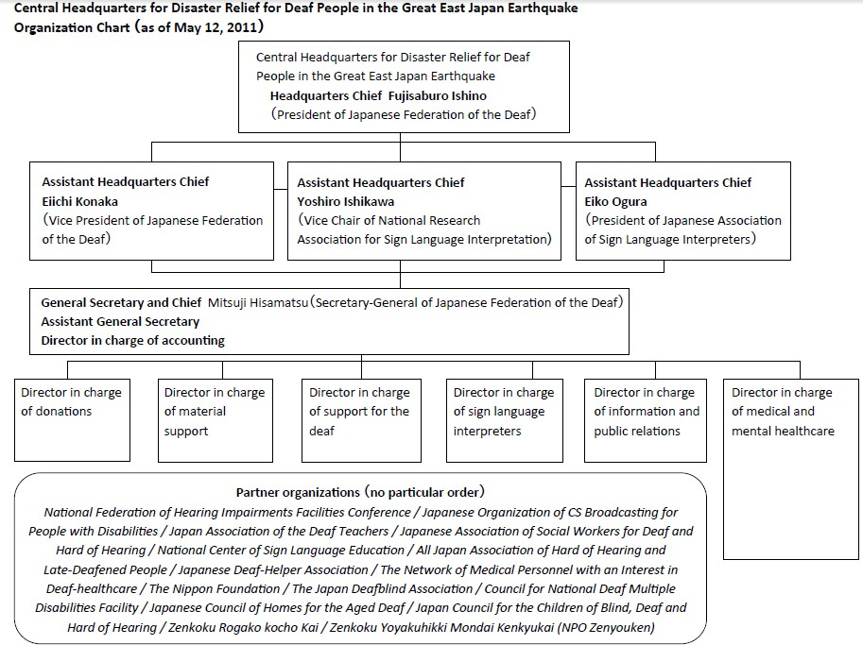
The JASWDHH started the disaster relief project called Deaf Support Nakama funded by the Nippon Foundation and American Jewish Association in July 2011 (JASWDHH, 2012). The Deaf Support Nakama project delivered psychotherapy and case management services provided by licensed clinical social workers with knowledge of the deaf population and fluency in Japanese Sign Language (see Figure 3) through 2011 to 2015. The JASWDHH also sent a deaf licensed social work coordinator to Miyagi Prefecture, and that coordinator remained through the 2011–2012 year. The office of the coordinator in Miyagi was located in the Prefecture’s JASWDHH headquarters, where the deaf licensed social work coordinator consulted and supervised Miyagi deaf peer counselors and sign language interpreters, and provided outreach supports in Fukushima and Iwate prefectures to develop their DRR and emergency plannings with local governments. The social work coordinator also provided consultation for local governments and local community agencies unfamiliar with how to work with deaf and hard of hearing populations. After the social work coordinator engaged with the intake of deaf clients, requests were sent to the central headquarters to dispatch a licensed clinical social worker to provide case management and counseling. The Deaf Support Nakama and JFD’s central headquarters also provided professional DRR training to local deaf and hard of hearing leaders to be a DRR and Emergency Planner for their local deaf communities. In addition to the training, the Deaf Support Nakama developed a program on Psychological First Aid (PFA), which was translated into Japanese Sign Language by a deaf social worker and deaf psychologist and made available on YouTube to increase its dissemination to the deaf community. Years after the post-Tohoku earthquake, many local deaf associations successfully conducted DRR training projects and emergency plannings with their local governments (Kurano, 2021; Tokyo Newspaper, 2022).

Figure 3
JASWDHH’s Deaf Support Nakama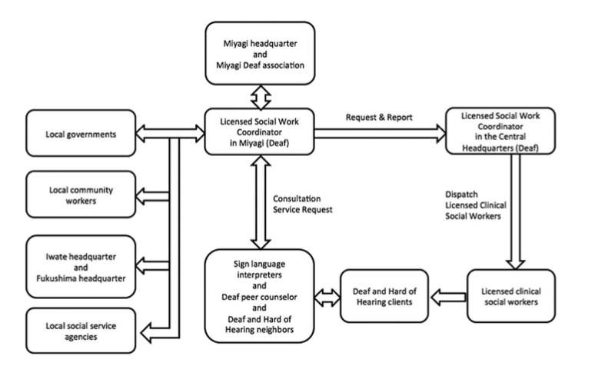

Conclusion

Twin-track approaches have been used in various domains of development practice for some time and have been shown to have demonstrably better outcomes for training with historically marginalized and multiple intersectional communities (CBM International 2021; UNDESA 2016). Accordingly, proposing a twin-track approach to DRR training would seem to be uncontroversial; however, in practice, particularly in the context of the global disability inclusion projects, all four authors have witnessed growing resistance to proposals that involve twin-track training for deaf communities, including ideological reference to separatist intentions. These claims obscure the fact that most deaf people around the world have limited access to education–and thereby also limited access to information and communication in majority languages, and also limited access to multilingual sign language and communication resources and services. Presenting DRR training in a majority language (i.e., PowerPoint with signed-spoken language interpretation) does not resolve the impacts of educational or social resource exclusion. Bridge approaches to training and twin-track training thereby utilize the collective knowledge, skills, and organizing power of deaf communities to redistribute decision-making power and resources, enabling deaf people to guide their own DRR training processes and capacity development.

References
Burch, S., & Kafer, A. (2010). Deaf and Disability Studies : Interdisciplinary Perspectives. Gallaudet University Press. http://ebookcentral.proquest.com/lib/usyd/detail.action?docID=4860676
Calgaro, E., Craig, N., Craig, L., Dominey-Howes, D., & Allen, J. (2021). Silent no more: Identifying and breaking through the barriers that d/Deaf people face in responding to hazards and disasters. https://hdl.handle.net/2123/24662
Calgaro, E., & Dominey-Howes, D. (2013). Increasing the resilience of the Deaf Community in NSW to natural hazards.
CBM International. (2021). Disability-Inclusive Development Toolkit. Germany: CBM
International.
CFE-DMHA. (2021). Vietnam Disaster Management Reference Handbook. Hickam,Hawai'i: Center for Excellence in Disaster Management and Humanitarian Assistance.
Cooper, A. C., Bùi, H. T. T., Nguyễn, L. T., Nguyễn, P. K., Nguyễn, T. H. T., & Phan, D. P. N. (2021). Deaf-led organizations and disaster communication in Việt Nam: Interdisciplinary insights for disability inclusive disaster risk reduction planning. International Journal of Disaster Risk Reduction, 65, 102559. https://doi.org/https://doi.org/10.1016/j.ijdrr.2021.102559
Cooper, A.C. and Nguyễn, N.T.T. (2015). Signed Language community-Researcher
Collaboration: Challenging Language Ideologies, Creating Social Change. Journal of Linguistic Anthropology, 25(2): 105–128.
Cooper, A.C. (2017). Deaf to the Marrow: Deaf Social Organizing and Active Citizenship in Việt Nam. Washington, DC: Gallaudet University Press.
Craig, L., Craig, N., Calgaro, E., Dominey-Howes, D., & Johnson, K. (2019). People with disabilities: Becoming agents of change in disaster risk reduction. In F. I. Rivera (Ed.), Emerging Voices in Natural Hazards Research (327-356). Butterworth-Heinemann https://doi.org/10.1016/B978-0-12-815821-0.00020-5
Craig, L., Johnson, K., Calgaro, Emma. (2017). Disability and Disasters: Empowering people and building resilence to risk.
Cripps, J. H., Cooper, S. B., & Austin, E. N. (2016). Emergency Preparedness with People Who Sign: Toward the whole community approach. Journal of emergency management (Weston, Mass.), 14(2), 101-111. https://doi.org/10.5055/jem.2016.0277
De Meulder, M., Kusters, A., Moriarty, E., & Murray, J. J. (2019). Describe, don't prescribe. The practice and politics of translanguaging in the context of deaf signers. Journal of Multilingual and Multicultural Development, 40(10), 892-906. https://doi.org/10.1080/01434632.2019.1592181
Engelman, A., Ivey, S. L., Tseng, W., Dahrouge, D., Brune, J., & Neuhauser, L. (2013). Responding to the deaf in disasters: establishing the need for systematic training for state-level emergency management agencies and community organizations. BMC health services research, 13(1), 84-84. https://doi.org/10.1186/1472-6963-13-84
Harrelson, E. M. (2019). Deaf people with “no language”: Mobility and flexible accumulation in languaging practices of deaf people in Cambodia. Applied Linguistics Review, 10(1), 55-72. https://doi.org/doi:10.1515/applirev-2017-0081
Ivey, S. L., Tseng, W., Dahrouge, D., Engelman, A., Neuhauser, L., Huang, D., & Gurung, S. (2014). Assessment of state- and territorial-level preparedness capacity for serving deaf and hard-of-hearing populations in disasters. Public health reports (Washington, D.C. : 1974), 129(2), 148-155. https://doi.org/10.1177/003335491412900208
Lane, H. (1992). The mask of benevolence : Disabling the deaf community (1st ed.). Knopf.
Padden, C., & Humphries, T. (1988). Deaf in America : Voices from a culture. Harvard University Press.
Padden, C., & Humphries, T. (2005). Inside deaf culture. Harvard University Press.
Palfreyman, N. (2019). De Gruyter Mouton. https://doi.org/doi:10.1515/9781501504822
Roberts, G. (2018). Get Ready: A model for deaf community leadership and preparedness. Australian Journal of Emergency Management, 7-8. https://knowledge.aidr.org.au/resources/ajem-jul-2018-get-ready-a-model-for-deaf-community-leadership-and-preparedness/
Statistics Indonesia. (2015). Profile of Indonesia Population https://www.bps.go.id/publication/2016/11/30/63daa471092bb2cb7c1fada6/profil-penduduk-indonesia-hasil-supas-2015.html
Takayama, K. (2017). Disaster Relief and Crisis Intervention with Deaf Communities: Lessons Learned from the Japanese Deaf Community. Journal of Social Work in Disability & Rehabilitation, 16(3-4), 247-260. https://doi.org/10.1080/1536710X.2017.1372241
WFD. (2019). Complementary or diametrically opposed: Situating Deaf Communities within 'disability' vs 'cultural and linguistic minority' constructs: Position Paper.
World Risk Report. (2019). World Risk Report - Focus: Water Supply. Bonn & Berlin, Germany: Bündnis Entwicklung Hilft.

Deaf Community and DiDRR: Supporting a Twin-Track Approach By Leyla Craig, Audrey Cooper, Kota Takayama, and Herbert Klein https://rdsjournal.org/index.php/journal/article/view/1178 is licensed under a Creative Commons Attribution 4.0 International License. Based on a work at https://rdsjournal.org.

