Research Articles and Essays

Parent Involvement in Promoting Social Integration in Elementary Schools in Canada – A Preliminary Teachers’ Report

Lily Dyson

University of Victoria, Victoria, B.C., Canada

Abstract
Parent involvement in children’s education is crucial to their education. It may also facilitate the social integration of children with disabilities which has been advocated but which has been lacking. To effectively involve parents in promoting social integration, information is needed. Of interest would be knowledge of parents’ support of social integration and the role they play in promoting it. These questions were investigated based on teachers reports. Using a qualitative inquiry method, the research found only partial parent support and participation. Implications for advancing practice and research are suggested.
Keywords: parent involvement, social integration, children with disabilities, education

Parent Involvement in Promoting Social Integration in Elementary Schools in Canada – A Preliminary Teachers’ Report
Parent involvement in children’s education is crucial to children’s development and education and has indeed long been promoted. Research has shown a significant association between parent involvement and a child's academic performance beyond the impact of the child's intelligence (Topor et al., 2010). Literature reviews have concluded that students with strong parent involvement are more likely to attend school regularly and stay in school longer, earn high grades, show appropriate behavior, and graduate to enter higher education (Henderson & Mapp, 2002; Jeynes, 2005). Parent involvement in special education, such as in Individualized Education Program (IEP) meetings, is mandated in the U.S. (Goldman & Burke, 2017).
Parent involvement is broadly defined as various types of parent engagements (Zhang et al., 2011). Grossly, parent involvement is classified into home-based activities engaged between the parent and the child such as outside of school. Parent involvement also includes school-based activities, which include child-focused activities typically conducted at school (Fishman & Nickerson, 2015). Despite its influence on children’s education and development, parent involvement is less studied in special education (Zhang et al., 2011). Even less, if any, research has examined parent involvement within the school in the broader context such as promoting social integration for children with disabilities or other special needs.
Inclusion of children with disabilities in the regular class has been ardently called for since 1990s (Stainback & Stainback, 1990). Inclusion has long been legislated in the United States such as in the Individuals with Disabilities Education Act (IDEA) (Goldman & Burke, 2017). Inclusion is considered to benefit all aspects of child development for children with disabilities (Stainback & Stainback, 1990). A major purpose of inclusion is to cultivate social inclusion. “Social inclusion matters in K-12 school,” according to Juvonen et al. (2019, p. 251). Based on research, social inclusion is defined as “the presence of reciprocal friendships, interactions between special education needs (SEN) and non-special needs (non-SEN) students, the social status of SEN students as perceived by non-SEN students, and the acceptance of SEN students by their classmates” (Vyrastekova, 2021, p. 1).
Researchers and educators have advanced the term “social inclusion” to “social integration.” Social integration is specifically applied to people with disabilities (McCay & Keyes, 2001). A main goal of inclusion, also commonly referred to as mainstreaming, is the social integration of children with disabilities or other special needs. However, social integration is far from being achieved in the U.S. or Canada even today. A lack of social inclusion for children with disabilities has persistently been reported. Earlier studies found that preschool students with disabilities experienced rejection and low acceptance from peers (Odom et al., 2002). Children with disabilities were found to be less popular and had fewer friends than their nondisabled peers (Avramidis, 2013). More recent studies found that a child with Down syndrome would be less socially accepted than a child without disability (Schwab et al., 2016). Adolescents with autism were reported to be lonely and lacking friendship in an inclusive school setting (Locke et al., 2010). In a study, students with hearing impairment reported feeling less socially integrated and less accepted by their peers. They interacted more with other students with special needs. Social inclusion for children with disabilities continues to be an elusive and difficult goal (Koller & Stoddart, 2021).
There is a clear need for promoting social integration in schools and communities. Given the potential influence parents possess in children’s lives and education, they have a role to play in contributing to the fulfillment of social integration. Of beginning interest are whether parent involvement takes place and what type of involvement they assume in promoting social integration. No studies have examined parental involvement in this regard.
The ecology of human development proposes that the child is surrounded by a set of overlapping layers of sub-ecological environments which would impact their development (Bronfenbrenner, 1979). The most intimate sub-ecological environment is the home, which is normally headed by parents. Parents’ participation in their children’s education would have a crucial impact on their children’s development. Because parents are inherently supportive of their children’s education as literature has shown, parents would be expected to support an important school activity such as promoting social integration. With various parenting skills, parents could also employ methods to help promote the social integration of children with disabilities. These assumptions were tested in the present study.
Legislation such as the IDEA advises that educators form partnerships with parents, specifically in the field of special education. It also requires schools to allow parents to participate in all phases of educational assessment and planning for students who receive special education services. Parent collaboration is thus important especially in the field of education. For optimal collaboration, teachers’ opinions become pivotal. Teachers’ perspective and experience with parent involvement in the promotion of social integration would provide a good start toward actions to plan and generate effective parent involvement in such a movement. Teachers’ reports have been published to inform various aspects of education concerning disabilities (Laia & Gil, 2014). This study thus examined parent involvement in promoting social integration based on the perception and experience of elementary school teachers in Canada. As a pilot study, certain beginning questions have arisen which are: (a) what is the state of parent involvement in the form of support for social integration; and (b) What kinds of parent involvement are taking place? The answer would help planning and programs to promote the social integration of children with disabilities.

Method

Participants
The participants were 54 Canadian elementary school teachers, all but one of whom taught regular classes. The one exception taught special classes. The schools are located in a metropolitan city with a population of 360,000 in the Pacific-West region of Canada. The Canadian teachers taught kindergarten through Grade 7. The schools had a student population ranging from 200 to 650. The teachers had varying degrees of teaching experience, from 2 to over 30 years. Privacy prevented the collection of information on the teachers’ ages. There were 15 males and 39 females.

Procedure
With the approval of the university research ethics committee and the initial approval by the school principal, the researcher verbally presented a written description of the project to the teachers as a group or individually. Teachers took part in the study voluntarily with a verbal and written consent.
The teachers were interviewed by the researcher. Each interview was facilitated by a questionnaire devised to examine issues surrounding social integration. Interviews were tape-recorded and later transcribed.
Instrument
This study is part of a larger study which applied a set of questions concerning various aspects of social integration. The questions related to the present study were: (1) How much parent support is there in your school for social integration of children with disabilities; (2) What role do parents play in facilitating social integration?

Data Analysis
The transcribed interview data were analyzed according to the questions, using the content analysis method (Johnson & LaMontagne, 1993). Each word, phrase, or sentence related to the topic being asked constituted a unit of analysis. Major categories were first identified after comparisons were made for similarities and differences between each smaller category or concept. Major categories were subsequently used for coding the rest of the data. New themes were added as they emerged. The coding reliability was further examined by comparing between the two coders. The reliabilities for the entire data were 78% to 90%, with an average of 81%.

Results
Results are presented by the research questions as follows:

Degree of Parental Support
Table 1 below presents themes and frequency of teachers' responses to the question: “In your class, how much parent support is there for the social integration of children with special needs/disabilities?”

Table 1
Degree to Which Parents Supported Social Integration Based on Teacher Responses
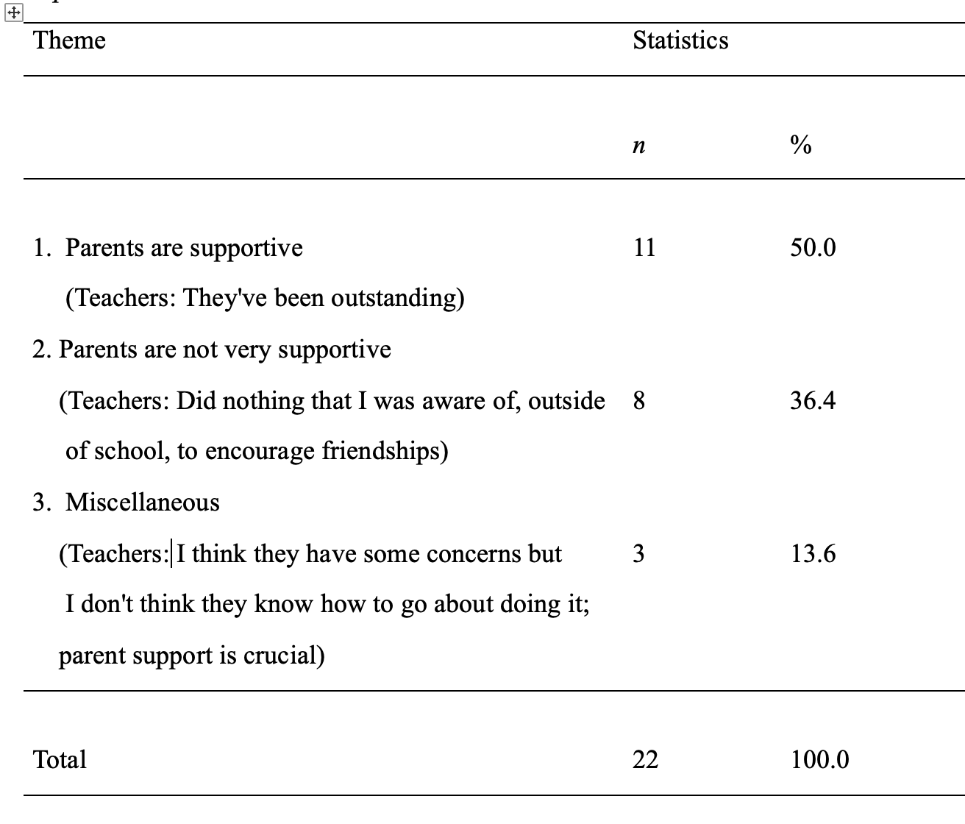
As seen in Table 1, only 40% of the teachers responded to the question. Of the responses, half of them reported that parents were supportive of social integration while 36% of the teacher gave a negative response. As one teacher remarked, “Parents did nothing that I was aware of, outside of school, to encourage friendships.” Another 14% had mixed reaction. One reason for the mixed response was that, despite support for social integration, some parents lacked the ability to promote it. Another reason for the non-supportive response was the teacher’s lack of knowledge of the parents’ stance and views regarding social integration.

Type of Parental Support
Table 2 presents themes and frequency of teachers' responses to the question: “What role have parents been taking in facilitating social integration?”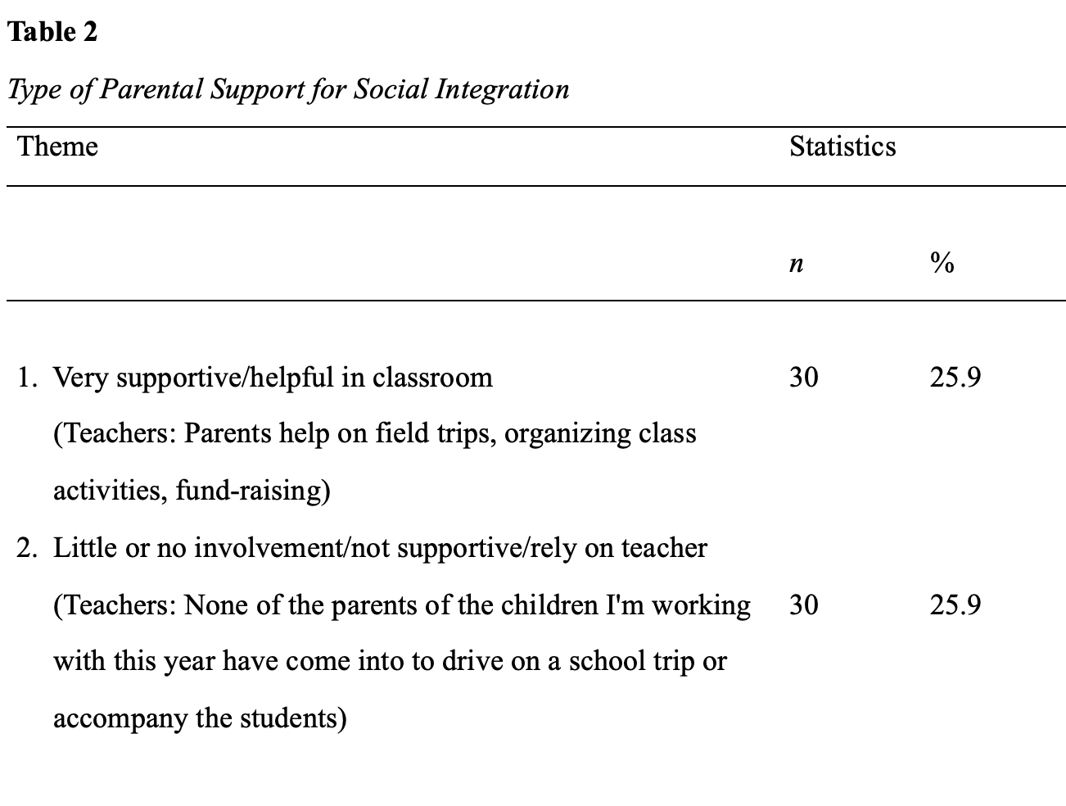
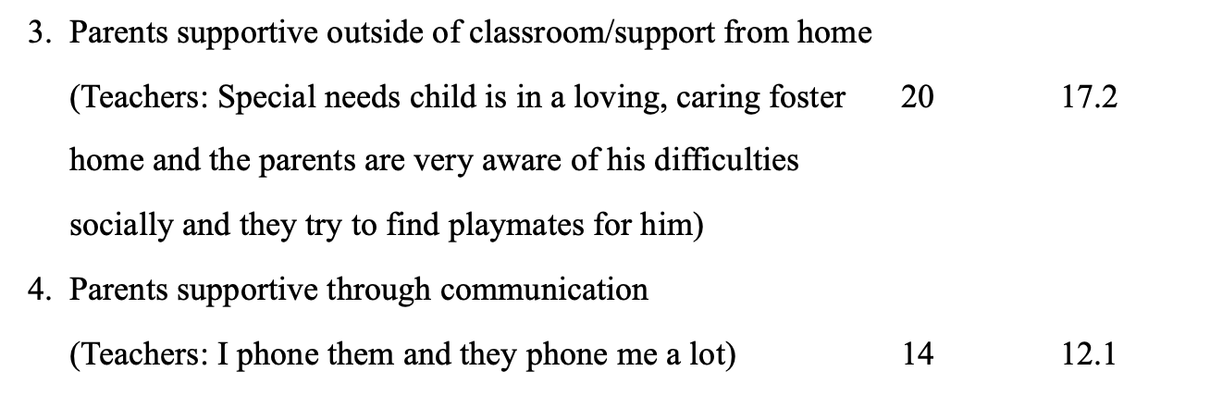
.

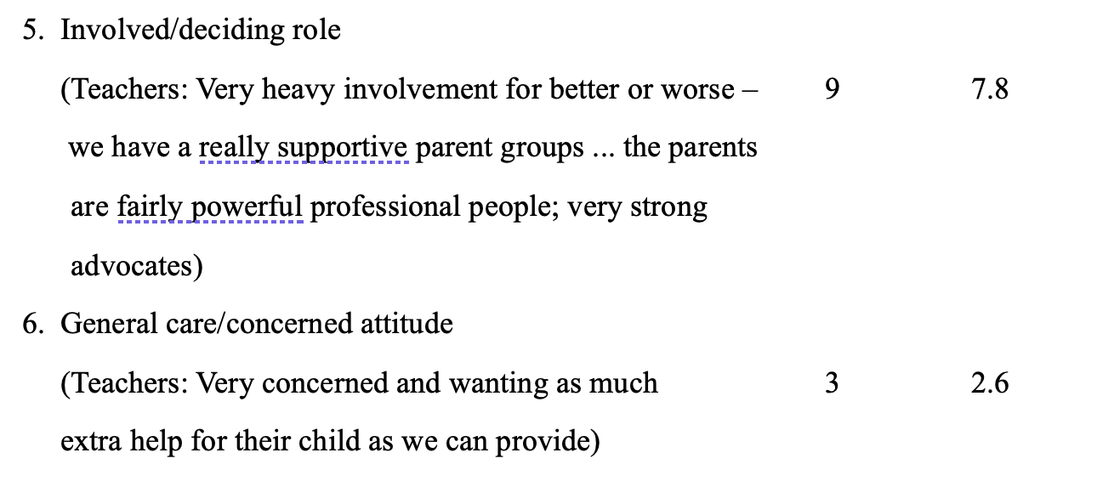
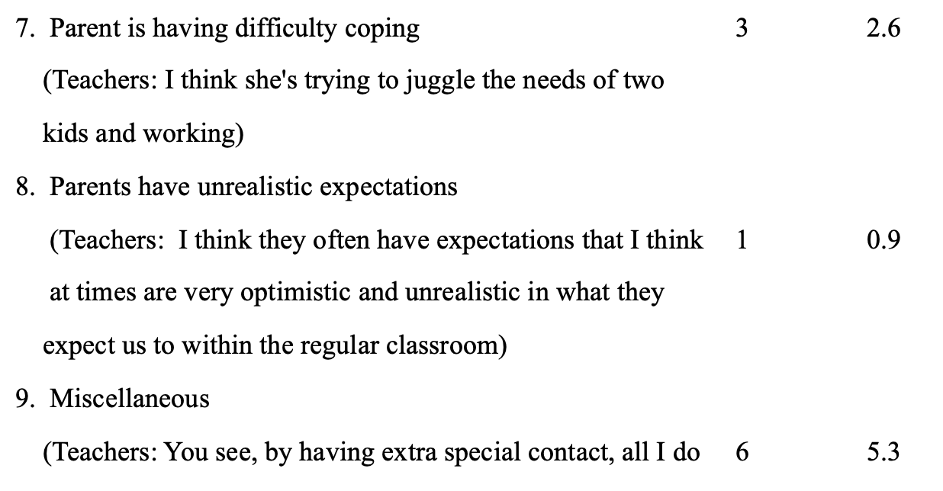

Various levels of parent involvement were revealed from the teachers’ responses to the question of “What role have parents been taking in facilitating social integration?” The responses ranged from very positive to non-supportive. The same percentage (26%) of presence of parental support and absence of parental support was also reported. Parental support was provided through various means of involvement in the school such as help on field trips, organizing class activities, and fund-raising. A significant percentage (17%) was reported to have provided support outside the classroom and at home. Inviting classmates to the child’s house was a major form of parental support. Another common form of parental support was through communication between school and parents of children with disabilities (12%). Still another common means of parental support (7%) appeared in parents serving as “very strong advocates.”
On the other hand, there were parents who lacked the skill to provide support for the social integration of children with disabilities (3%). The lack of parental support was also attributed to the teachers’ view that the children’s home and culture, not the parent alone, were responsible for the promotion of social integration.

Discussion
This study examined parent involvement in promoting social integration of children with disabilities. The study was prompted by the lack of social integration of such children and the importance of parent involvement in children’s education which may serve as a potential source for increasing social integration. Based on the teacher’s reports, the results failed to confirm the expectations as would be predicted by the ecological model of human development (Bronfenbrenner, 1979) and by research. The research found instead that only half of the parents were in support of social integration philosophically and were providing the actual support. Moreover, where parent support was delivered, the activities were limited to participating in regular school activities such as driving for field trips, participating in some classroom activities, and fundraising. Occasional support involved inviting playmates to the home of children with disabilities.
The study thus found parent involvement has yet to be enhanced. It is unknown why parents do not support social integration aside from the fact that some parents lacked the resources or knowledge for providing support for social integration.
The results suggest that despite the potential for parents to help educate their children and promote their social development, parents have been underutilized in promoting social integration. There is therefore the need to increase parent involvement in promoting social integration. As the study shows that parents may not have the knowledge or the skill for such an undertaking, short-term workshops or information sessions may be helpful to educate parents in promoting social integration. Schools, with government funding, may facilitate such a program.
Moreover, a child with disabilities poses challenges for parents (Ludlow et al., 2012). In comparison to parents of nondisabled students, parents of students in special education encounter greater barriers to involvement and are less involved (Dyson, 1997; Fishman & Nickerson, 2015). To promote social integration, it may be helpful to enlist the help of parents of children with disabilities with special support such as transportation, information sessions for promoting social integration or baby-sitting to facilitate their participation.
Alarmingly, the study found that only a small number of teachers reported whether there was parent support for social integration. This observation does not imply the lack of parental support. Rather, it suggests that there may be a lack of knowledge among the teachers about parents’ participation in promoting social integration. The phenomenon speaks to the possible lack of teacher-parent cooperation in social integration. Schools may consider increasing efforts or developing programs to encourage more teacher-parent cooperation for the promotion of social integration.
This study pilots the research and provides preliminary information on parent involvement in promoting social integration. Further research may extend the present findings and begin a more systematic examination and exploration of parent involvement for the promotion of social integration for children with disabilities. Many issues regarding parent involvement remain to be addressed in research. One may well be the definition of social integration, which has to date not been clearly defined. The definition with its main components would serve as a starting point for activities and programs for a systematic approach to promoting social integration or social inclusion. Only through systematic research, planning, and program delivery can society in general and schools in particular improve the social integration and inclusion of children and adults with disabilities. A clear definition would also provide a guide for systematic research of social integration: in theory and in practice.

References
Avramidis E. (2013). Self-concept, social position and social participation of pupils with SEN in mainstream primary schools. Research Papers in Education, 28, 421–442.
Bronfenbrenner, U. (1979). The experimental ecology of education. Educational Researcher, 5, 5-15.
Dyson, L. L. (1997). Fathers and mothers of school-age children with developmental
disabilities: Parental stress, family functioning, and social support. American Journal on Mental Retardation, 102, 267–269. https://doi.org/10.1352/0895-8017(1997)102<0267:FAMOSC>2.0.CO;2
Fishman, C. E. & Nickerson, A. B. (2015). Motivations for involvement: A preliminary
investigation of parents of students with disabilities. Journal of Child and Families
Studies, 24, 523–535.
Goldman, S. E.; and Burke, M. M. (2017). The effectiveness of interventions to increase parent involvement in special education: A systematic literature review and meta-analysis. Exceptionality: A Special Education Journal 25, 97-115. https://doi.org/10.1080/09362835.2016.1196444
Henderson, A. T., & Mapp, A. L. (2002). A new wave of evidence: The impact of school, family, and community connections on student achievement. Austin, TX: Southwest Educational Development Laboratory, National Center for Family and Community Connections with Schools.
Jeynes, W. H. (2005). A meta-analysis of the relation of parental involvement to urban
elementary school student academic achievement. Urban Education, 40, 237- 269. https://doi.org/10.1177/0042085905274540
Johnson, L. J., & LaMontagne, M. J. (1993). Research methods using content analysis to examine the verbal or written communication of stakeholders within early intervention. Journal of Early Intervention, 17(1), 73–79.
https://doi.org/10.1177/105381519301700108
Juvonen, J., Lessard, L. M., Ritika Rastogi, R., Schacter, H. L., & Smith, D. S. (2019).
Promoting social inclusion in educational settings: Challenges and opportunities.
Educational Psychologist, 54, 250–270.
Laia, Y. C. & Gil, J. (2014). Multiple perspectives on integrated education for children with disabilities in the context of early childhood centres in Hong Kong. Educational Review, 66, 345–361. http://dx.doi.org/10.1080/00131911.2013.780007
Locke, J., Ishijima, E. H., Kasari, C., & London, N. (2010). Loneliness, friendship quality and the social networks of adolescents with high-functioning autism in an inclusive school setting. Journal of Research in Special Educational Needs, 10, 74-81. https://doi.org/10.1111/j.1471-3802.2010.01148.x
Ludlow, A., Skelly, C., & Rohleder, P. (2012). Challenges faced by parents of children diagnosed with autism spectrum disorder. Journal of Health Psychology, 17(5), 702– 711. https://doi.org/10.1177/1359105311422955
Koller, D., & Stoddart, K. (2021). Approaches that address social inclusion for children
with disabilities: A critical review. Child & Youth Care Forum, 50, 679–69.
McCay, L. O., & Keyes, D. W. (2001). Developing social competence in the inclusive primary classroom. Childhood Education, 70, 70-78.
Odom, S. L., Zercher, C., Marquart, J., Li, S., Sandall, S., & Wolfberg, P. (2002). Social relationships of children with disabilities and their peers in inclusive classrooms. In S. L. Odom (Ed.), Widening the circle: Including children with disabilities in preschool programs (pp. 61-80). Teachers College Press.
Schwab, S., Huberb, C., & Gebhardt, M. (2016). Social acceptance of students with Down
syndrome and students without disability. An International Journal of Experimental
Educational Psychology, 36, 1501-1515.
Stainback W., & Stainback S. (Eds.) (1990). Support networks for inclusive schooling: Interdependent integrated education. Paul H. Brookes.
Topor, D., R., Keane, S. P., Shelton, T. L., & Calkins, S. (2010). Parent involvement and student academic performance: A multiple mediational analysis. Journal of Prevention & Intervention in the Community, 38,183-197. https://doi.org/10.1080/10852352.2010.486297
Vyrastekova, J. (2021). Social inclusion of students with special educational needs assessed by the Inclusion of Other in the Self scale. PLoS ONE 16(4): e0250070.
https://doi.org/10.1371/journal.pone.0250070
Zhang, D., Hsu, H.-Y., Kwok, O.- M., Benz, M., & Bowman-Perrott, L. (2011). The impact of basic-level parent engagements on student achievement: Patterns associated with
race/ethnicity and socioeconomic status (SES). Journal of Disability Policy Studies, 22(1), 28–39. https://doi.org/10.1177/1044207310394447

Parent Involvement in Promoting Social Integration in Elementary Schools in Canada – A Preliminary Teachers’ Report by Lily Dyson. https://rdsjournal.org/index.php/journal/article/view/1358 is licensed under a Creative Commons Attribution 4.0 International License. Based on a work at https://rdsjournal,org

