**Media Review**

**A Troubling Place:   
Disability and *A Quiet Place: Day One* (2025), A Review**Raphael Raphael,   
Center on Disability Studies, University of Hawaiʻi at Mānoa

**Abstract**

This review of the latest edition of the popular franchise praises the film for its compelling performances and narrative while bringing attention to its troubling ableist fantasy of a future without disabled people.

*Keywords*: disability, film, ableism, science fiction, horror

**A Troubling Place:   
Disability and *A Quiet Place: Day One* (2025), A Review**Raphael Raphael   
Center on Disability Studies,

University of Hawai'i at Mānoa

**Abstract**

This review of the latest edition of the popular franchise praises the film for its compelling performances and narrative while bringing attention to its troubling ableist fantasy of a future without disabled people.

*Keywords:* film, representations, disability, horror, science fiction, ableism

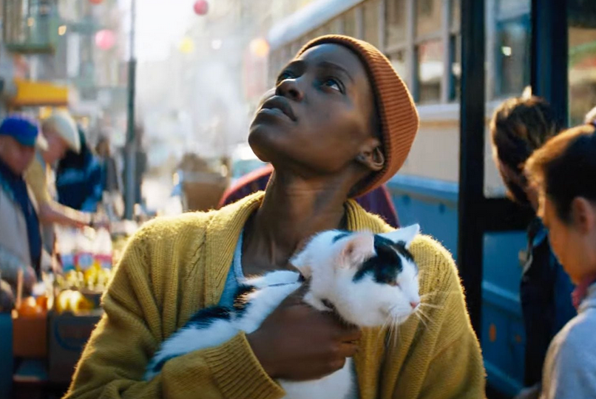

***A Quiet Place: Day One*** is a relentless, epic journey that thrusts us back to the origins of the franchise’s terrifying silence. It’s intense, beautifully shot, and gripping. But for those of us who think about disability and representation in film, it’s also a deeply frustrating ride — offensive in a way that feels so familiar it’s almost comforting. The first two A Quiet Place films were praised for their disability consciousness, particularly through the inclusion of deaf actress Millicent Simmonds and a narrative that appeared to invite a non-deficit model of disability (as I suggested in[RDS Vol 15, No 1](https://rdsjournal.org/index.php/journal/article/view/RDS%20Vol%2015%2C%20No%201).) This film is different.

The film follows a formula we’ve seen countless times before. Disabled characters, directly or indirectly, hold society back — or so the narrative implies. And as the story reassures us, it’s okay, because they would rather die anyway. It’s a trope that runs through cinema history, from *The Elephant Man* to *Million Dollar Baby*, where disabled lives are framed as tragic burdens rather than complex, valuable existences. The third installment of this franchise continues this legacy of minimizing the lives of people with disabilities in a way that feels particularly pointed.

Set in New York City on the day the alien invasion begins, the story features giant, sound-hunting monsters that decimate the noisy while sparing the silent who can hide their pain. Our heroine, played by the exceptional Lupita Nyong’o, is a jaded cancer survivor navigating her world with resilience and small comforts like her cat and her memories — especially of pizza. Nyong’o’s performance is remarkable, and her character’s quiet strength is compelling. But as the story unfolds, it becomes clear that her fate is sealed from the start.

In her final act alive (***major spoiler alert***), knowing that sound will summon the creatures, she blasts Nina Simone on the streets — a defiant and tragic choice. The scene is framed as empowering, but it rests on the same tired idea: that life with disability, accommodations, or dependence on medication is somehow unbearable. Instead of allowing the character to fight for survival or redefine her place in this brutal world, the story sends her to a noble death.

And it’s not just her. Earlier, as people walk together towards safety — in a moment when silence is crucial — the sound of the wheels of a wheelchair breaks the silence and endangers everyone: the message is clear — in the world of the film, keeping those with disabilities in our community is a risk we simply cannot afford. In a final boat sequence, a modern Ellis Island metaphor, humanity is divided into the worthy and the expendable — those who the narrative presents as mattering make the boat, leaving the disabled and “weak” behind. It’s a deeply unsettling undercurrent, suggesting that the future belongs only to those who meet a certain standard of strength and independence. This ignores the fact that historically having disabled people in communities (and efforts to accommodate them) makes everyone’s life better. (In real life, if you like SMS, velcro, smart home technology, curb cuts on sidewalks, subtitles on films, and the telephone itself, you can thank the presence of disability!)

To its credit, the film is a super-engaging ride. The pacing is relentless, the tension gripping, and the performances top-notch. But at its core, it fails to embrace the complexity of its premise. Instead of exploring how communities survive together — drawing on diverse skills and perspectives — it imagines a future purified of those who don’t ‘fit.’

This isn’t just a missed opportunity; it’s a troubling choice. It’s not that disabled people “want to die,” as the film implies — it’s that society often denies them the resources and support to fully live. *Day One* reinforces this upside-down narrative, assuring audiences that disabled folks are happy to disappear, sparing the rest of society from guilt or responsibility.

By the end of the film, the heroine’s cat finds a new home with the white male lead Joseph Quinn. Nyong’o’s character’s legacy is reduced to a mustard sweater and a cute letter. It’s a stark reminder that while the film asks us to root for survival, it really only imagines survival for some. Humans with vulnerabilities are left behind — not because they can’t make it, but because the story never gives them a chance.

***A Quiet Place: Day One (2025)*  
Director:** Michael Sarnoski  
**Writers:** John Krasinski, Michael Sarnoski  
**Cast:** Lupita Nyong’o, Joseph Quinn, Djimon Hounsou, Alex Wolff, Lauren Ridloff  
**Genre:** Horror, Sci-Fi, Thriller  
**Runtime:** 1 hour 43 minutes  
**Rating:** PG-13 (violence, terror, thematic elements, brief strong language)

**References**

Sarnoski, M. (Director). (2025). *A quiet place: Day one* [Film]. Paramount Pictures.

Creative Commons CC:BY logo **A Troubling Place: Disability and *A Quiet Place: Day One* (2025), A Review**

by Raphael Raphael <https://rdsjournal.org/index.php/journal/article/view/1392> is licensed under a [Creative Commons Attribution 4.0 International License](http://creativecommons.org/licenses/by/4.0/). Based on a work at<https://rdsjournal.org>.