Conference Proceedings

Creating Inclusive Campuses: The Impact of Disability Student Advocacy Clubs
Amanda Patrick, Megan Theobald, and Kiriko Takahashi
Center on Disability Studies, University of Hawai'i at Mānoa

Author Note
Eddie Bernice Johnson INCLUDES Initiative: The Alliance of Students with Disabilities for Inclusion, Networking, and Transition Opportunities in Science, Technology, Engineering, and Mathematics (TAPDINTO-STEM) is supported by the National Science Foundation under NSF Award 2119902. Any opinions, findings, and conclusions or recommendations expressed in this material are those of the author(s) and do not necessarily reflect those of the National Science Foundation.

Abstract
Disability student advocacy clubs play a significant role in promoting student retention by offering peer support, raising awareness, and advocating for more accessible and inclusive campuses. This literature review uses quantitative and qualitative research from various colleges and universities and a student survey on The Alliance of Students with Disabilities for Inclusion, Networking, and Transition Opportunities in STEM (TAPDINTO-STEM) program to present the benefits of such clubs. We found that student advocacy clubs improved academic outcomes, increased graduation rates, and enhanced social integration for students with disabilities (SWDs) in science, technology, engineering, and mathematics (STEM) fields.
Keywords: STEM inclusion, advocacy clubs, student well-being, students with disabilities

Inclusive Campuses: The Impact of Disability Student Advocacy Clubs
Including students with disabilities in higher education settings is crucial for fostering a diverse and supportive learning environment, especially for those going into STEM fields. Lee (2010) found that although students with disabilities (SWDs) are more likely to select STEM majors, they disenroll in these fields at a substantially higher rate than students without disabilities (Lee, 2010). STEM SWDs experience low graduation rates and face lower rates of employment in STEM careers than their peers (Schearer et al., 2022). Despite 19% of STEM students having a disability, disabled students make up only 7% of recent STEM graduates. (Schearer et al., 2022).
Educational barriers faced by SWDs in STEM include low expectations of instructors, accessibility barriers, lack of postsecondary education services, limited exposure to prerequisite courses, social/communication challenges, inconsistent accommodations, difficulty disclosing disability to faculty, and lack of disabled mentors (Dunn et. al., 2012; Powers et al., 2014; Thompson-Ebanks, 2014; Schearer et. al., 2022). In one study, students with learning disabilities lowered their STEM aspirations even after receiving virtual mentoring due to academic difficulties throughout their coursework (Gregg et. all, 2016).
Social barriers faced by SWDs in STEM include feelings of inadequacy, little sense of belonging, perceived lack of acceptance by families, teachers, and peers, and low expectations for college socialization (Hodges & Keller, 1999; Powers et al., 2014; Thompson-Ebanks, 2014). Other factors include difficulty integrating into university life due to social/pragmatic difficulty because of disability (Kaufman et al., 2024). In laboratory settings, SWDs experience a lower sense of belonging than their non-disabled counterparts and struggle in areas such as confidence and participation (Batty & Reilly, 2023).
Career and systemic barriers faced by SWDs in STEM include limited internship and networking opportunities, non-inclusive university policies, employment discrimination, lack of role models/individualized supports, and financial constraints (Powers et al., 2014; Schearer et al., 2022; Thompson-Ebanks, 2014). The accessibility of off campus fieldwork and internships can also limit potential opportunities for students with physical disabilities (Schearer et al., 2022).
Unfortunately, SWDs in STEM are less likely to use their accommodations than those pursuing other disciplines (Pfeifer et al., 2020). Accommodation barriers include social stigma and shame due to fear of having to disclose their disability to instructors (Pfeifer et al., 2020). However, working to improve levels of self-advocacy among undergraduate SWDs in STEM can help increase their academic retention rates (Pfeifer et al., 2020).

One Solution: Advocacy Clubs
This study aimed to explore advocacy clubs as a vehicle to improve outcomes for SWDs in STEM at the postsecondary level. We asked the following question: How can advocacy clubs for SWDs in STEM in postsecondary education improve their well-being? Student disability advocacy clubs are defined as a group of students, including SWDs and other allied students, who work together to promote inclusion, awareness, and support for students with disabilities on their campus and beyond (Web, 2025). Oftentimes, these advocacy clubs engage in activities related to peer support/inclusion, advocating for greater accessibility, and raising disability awareness on campus (Web, 2025).
Advocacy clubs have been shown to improve both academic and social outcomes for students with disabilities. Students’ peer classroom connectedness has been found to increase feelings of belonging in their academic major and university (Huber et al., 2022). A similar effect could be achieved through disability advocacy clubs, as students would see peers with disabilities pursuing STEM. This may lead to greater STEM enrollment by underrepresented groups, as identification with subgroups was shown to be a factor in social integration for SWDs (Hodges & Keller, 1999).
This paper highlights research into the benefits of advocacy clubs, including promoting inclusion for STEM SWDs. Additionally, we explore how the peer support networks formed by student advocacy clubs lead to improved well-being and academic success for SWDS in STEM. Finally, we offer practical guidance for establishing and sustaining such clubs, including strategies for recruitment, funding, and partnering with other organizations.

Methods
The study was conducted in two parts: a literature review of advocacy clubs and an evaluation of a student advocacy group developed under an National Science Foundation (NSF)-funded project called TAPDINTO-STEM. An electronic search was conducted between December 10, 2024, and April 14, 2025, using the following databases: ResearchGate, the NSF Eddie Bernice Johnson Alliance, PubMed, Sage Publications, Wiley Online Library, and Sage Journals. Search terms included “advocacy clubs & STEM,” “benefits of advocacy clubs & STEM students,” and “students with disabilities & STEM & advocacy clubs.” Articles that focused on the benefits of student or faculty-led advocacy clubs or mentoring programs for SWDs on campus in STEM were included in this review. Articles focusing on social integration strategies applicable to STEM for SWDs were also included as they can be used to support students in STEM-specific programs. Articles not applicable to SWDs in STEM fields were excluded. There were no restrictions on the region of publication or its original language.

Literature Review Results
The literature review search yielded a total of 26 articles, of which 24 met the inclusion criteria. One article was excluded because it only focused on barriers for SWDs in physics, but did not include advocacy clubs, mentoring, or social integration strategies. The other article described disability representation in STEM, but did not include advocacy clubs, mentoring, or social integration strategies. The articles included sequential mixed methods studies, randomized controlled trials, and qualitative studies from various universities and student organizations. Studies were conducted in the United States. Key preliminary findings, as summarized below, indicate that SWDs who participate in advocacy clubs report higher levels of self-efficacy, greater satisfaction with their college experience, and a stronger sense of belonging. The following is a discussion on the benefits of student advocacy clubs for students with disabilities in STEM fields.

Discussion

TAPDINTO-STEM Program Outcomes
Confidence in skills and understanding has been shown to increase when students feel included, and connections with peers can increase opportunities for learning (Batty & Reilly, 2023). This study examines the effectiveness of a program called The Alliance of Students with Disabilities for Inclusion, Networking, and Transition Opportunities in STEM (TAPDINTO-STEM) helping college students with disabilities. Effectiveness of the program was measured using student survey data collected throughout the 2023-2024 school year. The program utilizes mentoring as a key intervention tool to help students graduate in STEM fields and enter a STEM career. TAPDINTO-STEM program also encourages the development of student advocacy groups to change the campus climate surrounding disability (Thurston et al., 2024)
Participating students took online surveys about their experiences in both the fall 2023 and spring 2024 semesters. Figure 1 displays the results of “Students’ Perceived Outcomes.” Each item was rated on a 5-point Likert-type scale (1 = strongly disagree, 2 = disagree, 3 = neither agree nor disagree, 4 = agree, 5 = strongly agree). Figure 2 displays the survey results for “Students' Perceived Benefits from Program Engagement.” The measure consisted of 20 statements (e.g., “I am more confident that I will complete my degree program”). Participants rated the extent to which each statement applied to them on a 5-point Likert-type scale (1 = not at all, 5 = to a great extent).
The survey was conducted electronically. Questions measured the following areas:
- Student-reported sense of belongingness
- Students’ perceived benefits from program engagement
- Student responses to items on self-advocacy scale
- Student-reported academic efficacy
- Student-reported intent to persist

Results

Figure 1
Bar Graph of Students’ Perceived Outcomes by Semester
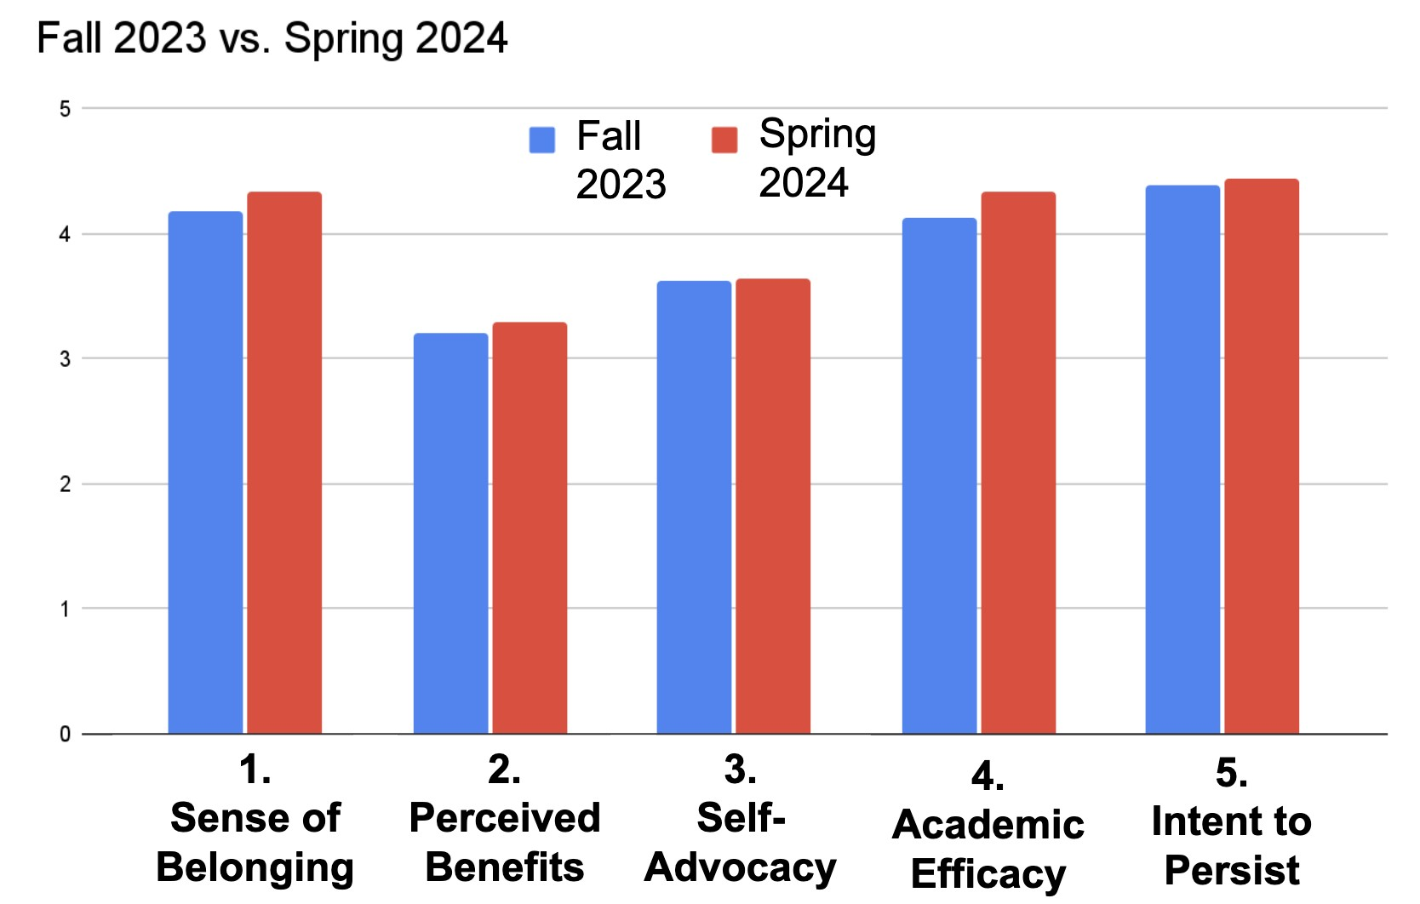
Note. From “NSF Eddie Bernice Johnson Alliance INCLUDES TAPDINTO-STEM Alliance Year 4 Annual Evaluation Report,” by L. P. Thurston, N. Johnson, L. Ashburn-Nardo, and Q. Zhi, 2024.

The study found important results regarding how students felt about their program and academic performance. Students in the NSF TAPDINTO-STEM program reported better outcomes in both the fall and spring semesters. They also reported a stronger sense of belonging in the program throughout the academic year. Additionally, by spring 2024, these students felt more confident in their academic abilities and were more likely to continue in their studies.

Promoting Inclusion
Other strategies for promoting inclusion through student advocacy groups include integrating disability-focused activities into broader campus activities on diversity. Framing disability as a matter of diversity and inclusion when partnering with campus administration also promotes greater inclusion on campus (Kreider et al., 2018).

Impact of peer support networks on well-being and academic success

Figure 2
Bar Graph of Students' Perceived Benefits from Program Engagement 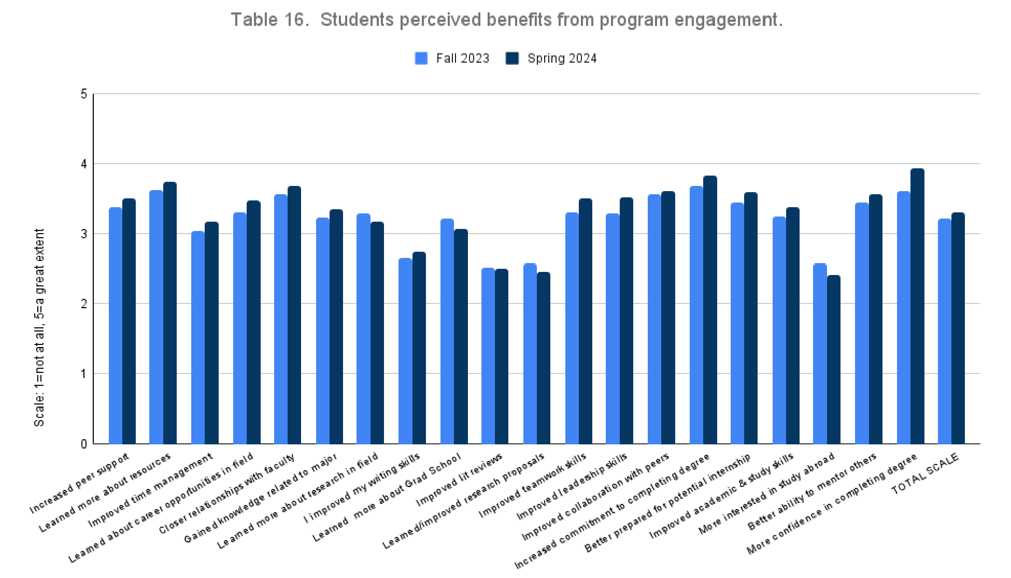Note. From “NSF Eddie Bernice Johnson Alliance INCLUDES TAPDINTO-STEM Alliance Year 4 Annual Evaluation Report,” by L. P. Thurston, N. Johnson, L. Ashburn-Nardo, and Q. Zhi, 2024.

As seen in the graph above, students reported moderate gains in the following areas:
  - increased peer support
  - learned more about resources
- improved time management Learned about career opportunities in the field
- closer relationships with faculty
- gained knowledge related to the major
- learned more about research in the field
- I improved my writing skills
- learned more about Grad School opportunities
- improved literature reviews
- learned/improved research proposals
- improved teamwork skills
- improved leadership skills
- improved collaboration with peers
- increased commitment to completing the degree
- better prepared for a potential internship
- improved academic & study skills
- more interested in studying abroad
- better ability to mentor others
- more confidence in completing the degree program

In summary, the TAPDINTO-STEM program and similar studies show improvements in self-efficacy, campus connection, professional development, and self-advocacy (Kreider et al., 2018; NSF INCLUDES TAPDINTO-STEM, 2022.)
Advocacy clubs have a positive impact on students’ social well-being as they are an important resource for fostering a sense of belonging among students with disabilities (Kaley et al., 2022). These clubs can promote community integration by providing opportunities to form and meet new friendships (Kaley et al., 2022). Local self-advocacy/social groups can also improve student perceptions of the on-campus environment, leading to easier transition into a university for first-year students (Kaley et al., 2022; Shepler & Woolsey, 2012). First-year students with disabilities encounter the same challenges with college transition as other students. Therefore, it is important to provide college transition-related support to this population as well. Support can be especially effective through disability-focused advocacy groups (Shepler & Woolsey, 2012).
STEM mentoring programs also resulted in significantly higher levels of STEM-related knowledge, engagement, confidence, and general career planning confidence for students who had mentors with or without disabilities (Sowers et al., 2016). Participation in a peer mentoring program increased graduation rates for students in underrepresented groups (34% graduation rates for students with mentors compared to 12.7% for matched controls) (Boutakidis et al., 2024).
Increasing the social capital of students with disabilities through building connections with others may also increase their ability to self-advocate (Pfeifer et al., 2020). Past studies have shown that disabled STEM students who had participated in communities meant to build their social capital reported higher levels of self-advocacy skills (Pfeifer et al., 2020). Disabled university students who engage in self-advocacy report higher GPAs as well as a higher likelihood of graduating when compared to controls (Pfeifer et al., 2020). Effective mentoring may help students feel more comfortable disclosing their disability and engaging in additional self-advocacy (Powers et al., 2014).

Best Practices
Best practices for establishing and sustaining advocacy clubs for SWDs include strategic recruitment, funding, and partnerships with other organizations. The first step in determining the best approach for organizations should be to assess student needs. It is not a one-size-fits-all approach, and each advocacy group should be tailored to the student population (Center on Disability Studies, University of Hawaiʻi at Mānoa, 2024).

Mentoring
Types of mentoring include formal mentoring, such as TAPDINTO-STEM, as well as informal mentoring, including UNITY (University of Hawaiʻi’s United Network of Inclusivity for Disabilities). Other mentoring models include student to student (e.g., Bridge to Baccalaureate Peer-Mentoring Program through TAPDINTO-STEM), and faculty/professional to student (e.g., Bridge to Post-Baccalaureate Peer-Mentoring Program
through TAPDINTO-STEM) (TAPDINTO-STEM Alliance, 2022).
Mentoring can be done in an individual, group, or virtual format. Mentoring can benefit SWDs by providing guidance on self-advocacy and accessing accommodations. Higher levels of support from faculty mentors, as well as more diverse mentor networks, promote integration into the STEM community through strengthening mentees’ professional identities and sense of belonging. Mentoring positively impacts the mentee’s career outcomes in STEM (Hernandez et. al., 2020). Mentoring also provides STEM students with role models, which is recommended for increasing representation in this field (Powers et al., 2014; Moon et al., 2012). Additionally, virtual mentoring had a significant impact on the academic persistence of STEM students with disabilities, with growth differences identified across types of disability and race/ethnicity populations (Gregg et al., 2016). The most significant improvements were in students’ perception of self-determination and self-advocacy (Gregg et al., 2016). Mentor/mentee pairing is an important factor to consider in promoting successful mentoring relationships. Club leaders should consider students’ preferences regarding what they are looking for in a mentor to ensure they have a good fit. Factors to consider include shared STEM interests, gender, common type of disability or other challenges, personality preferences of the mentees, and other interests (Powers et al., 2014). It is also important to consider the individual background of the student and the unique challenges they may face. For example, transfer students may need a different approach to mentoring as they benefited on a lesser scale compared to first-year students in a peer mentoring program (Boutakidis et al., 2024). Whether a mentor has a disability may also be a relevant factor when mentoring STEM students with disabilities. Studies show there are similar outcomes for STEM mentors with and without disabilities. However, STEM-related self-efficacy was higher when both mentor and mentee had disabilities (Powers et al., 2014).
Mentoring should focus on fostering positive attitude and self-determination as well as collaborative goal setting (Magill et al., 2013). This can be done by helping students identify their accommodation needs. SWDs tend to struggle with navigating the accommodation process once they reach college due to system differences from high school (Pfeifer et al., 2020). Student-led or faculty-led clubs can help students identify accommodations needed to meet their goals. Mentors can also provide career counseling through helping students find supportive educational programs or careers that meet their accommodation needs (Powers et al., 2014). Teaching various learning strategies and providing opportunities for real-world experience are also helpful to promote career exploration (Dunn, 2014).
Helping students identify their STEM interests and talents is also integral for effective mentoring. Workshops as well as bridging programs can be an effective solution for providing inexperienced students with a better understanding of lab work (Batty & Reilly, 2023). Students with attention deficit hyperactivity disorder (ADHD) who took part in a summer engineering research program reported a greater interest in engineering research, higher interest in graduate school, and a greater sense of belonging within the profession (Schearer et al., 2022). These results (greater interest in research, higher interest in graduate school, and greater sense of belonging) were achieved through identifying students’ strengths, which helped provide academic and psychosocial support (Kreider et al., 2018).

Events: Types & Purpose
Events play a crucial role in raising awareness about advocacy clubs for disabilities, promoting social integration, and highlighting various resources. Support and advocacy initiatives promote inclusion for SWDs and acceptance of neurodiversity (Center on Disability Studies, University of Hawaiʻi at Mānoa, 2024). These can include peer support groups, mentorship programs, and advocacy campaigns. Social events promote community building and a sense of connectedness among members (Center on Disability Studies, University of Hawaiʻi at Mānoa, 2024). Examples include the first-year students' welcome dinner, wellness/yoga events, and inclusive art workshops. Networking events promote networking between students and professionals. These may include game nights and accessibility awareness events for informal student-to-student networking. Career fairs and networking events with STEM professionals can help promote relevant resources.

Promote STEM-Specific Opportunities
STEM-specific opportunities can be promoted through creating an opportunities tracker spreadsheet, which helps students save various resources, such as relevant scholarships and internship opportunities, in a single document. Reviewing resumes with a mentor has also been helpful to students, as it provides education on effectively tailoring their resumes according to the work setting. Developing a STEM course plan and shadowing postgraduate student/faculty mentors are also helpful activities for individual or group meetings (Powers et al., 2014).

Other Recommendations
To ensure the continuation of student-led advocacy clubs, student leaders should encourage leadership development within the group through mentoring of potential student leaders. Collaboration with the community may also provide volunteer opportunities and mentoring (Center on Disability Studies, University of Hawaiʻi at Mānoa, 2024). To ensure advocacy clubs are meeting students’ changing needs, club leaders should also collect regular feedback from members through informal feedback or anonymous surveys (Center on Disability Studies, University of Hawaiʻi at Mānoa, 2024). Collaboration with similar organizations on campus can also broaden the impact of advocacy clubs through increased resources and potential members (Center on Disability Studies, University of Hawaiʻi at Mānoa, 2024). Finally, advocacy clubs can seek funding through grants, sponsorships, and fundraisers to support activities and events (Center on Disability Studies, University of Hawaiʻi at Mānoa, 2024).

Student Testimonials
As part of our study on the benefits of student advocacy clubs for disabilities, we asked TAPDINTO-STEM fellows and UNITY members, “How have neurodiversity mentoring programs impacted you? Please tell us about your experience.” Student responses are recorded below:
- When I transferred from community college, it was easy to feel disconnected in the larger environment. The mentoring program within TAPDINTO-STEM provided a community that helped me feel less isolated. As someone with neurodiversity, it can be challenging when you do not pick things up as quickly as others. This program gave me a space to share my experiences and learn from others, which helped me develop useful skills and stay on track with my education.
- It gave me a community I didn’t know I was missing. I transferred from a community college, where everything felt tight knit, to a university where I suddenly felt like just another face in a crowd. I had to start from scratch, building a support system. And for someone like me—who really leans on people to get through tough classes and stay grounded—it felt really isolating at first.
But when I joined the neurodiversity TADINTO-STEM group, things started to shift within my first semester. I realized my story wasn’t unique—and that was comforting. I saw familiar faces, met new ones, and it felt refreshing to gather biweekly just to check in on life. Everyone was going through it, just in slightly different ways. It helped me keep going.
One example of something we talked about was forming better habits and how to stay resilient when school isn’t going well. Hearing others echo the same frustrations I had—and share how they made it through—meant a lot. It reminded me I wasn’t alone.
- TAPDINTO-STEM has helped me in many ways, including offering a grant to conduct research, helping me write resumes, and providing encouragement at challenging times. I appreciate how friendly and supportive everyone is. Participating in this program has helped me significantly in my academic journey.

References

Batty, L., & Reilly, K. (2023). Understanding barriers to participation within undergraduate STEM laboratories: Towards development of an inclusive curriculum. Journal of
Biological Education, 57(5), 1147–1169. https://doi.org/10.1080/00219266.2021.2012227MDPI+4
Boutakidis, I., Espinoza, G., Sevier, M., & Sadek, A. (2024). The impact of a peer mentoring program on undergraduate graduation rates: A matched control group design. Journal of College Student Retention: Research, Theory & Practice. Advance online publication. https://doi.org/10.1177/15210251241268852
Center on Disability Studies, University of Hawaiʻi at Mānoa. (2024, November 13). Creating an advocacy club for students with disabilities at your institution. https://docs.google.com/document/d/1hX4O0CoPj6WQ2lI8VUXFdQlmPLlICWHmsUzg w7_z2SU/edit?usp=drive_link
Dunn, C., Rabren, K., Taylor, C., & Dotson, V. (2012). Assisting students with high-incidence disabilities to pursue careers in science, technology, engineering, and mathematics. Intervention in School and Clinic, 48(1), 47–54. https://doi.org/10.1177/1053451212443151
Dunn, C., Rabren, K., Taylor, C., & Dotson, V. (2014). Transitioning and preparing learners with special needs into STEM careers. https://www.researchgate.net/publication/297374885_Transitioning_and_preparing_learn ers_with_special_needs_into_STEM_careers
Gregg, N., Wolfe, G., Jones, S., Todd, R., & Moon, N. (2016). Virtual mentoring and persistence in STEM for students with disabilities. Career Development and Transition for Exceptional Individuals, 40(4), 205–214. https://doi.org/10.1177/2165143416651717
Hernandez, P. R., Agocha, V. B., Carney, L. M., Estrada, M., Lee, S. Y., Loomis, D., Williams, M., & Park, C. L. (2020). Testing models of reciprocal relations between social influence and integration in STEM across the college years. PLOS ONE, 15(9), e0238250. https://doi.org/10.1371/journal.pone.0238250
Hodges, J. S., & Keller, M. J. (1999). Perceived influences on social integration by students with physical disabilities. Journal of College Student Development, 40(6), 678–686. https://eric.ed.gov/?id=EJ614291
Huber, K. A., DeBacker, T. K., Klammer, C. C., & Gonzalez, L. R. (2022). Correlates of peer classroom connectedness among undergraduate women in STEM. Journal of Research in Science Teaching, 60(6). https://doi.org/10.1002/tea.21833
Kaley, A., Donnelly, J. P., Donnelly, L., Humphrey, S., Reilly, S., & Macpherson, H. (2022). Researching belonging with people with learning disabilities. British Journal of Learning Disabilities, 50(3), 307–320. https://doi.org/10.1111/bld.12394
Kaufman, T., Ziegler, L., Subramaniam, A., Hahn, R., & Mastin, H. (2024, September 30).
Autistic advocacy in higher education. [Canva slides].
https://www.canva.com/design/DAFv2tIyg7s/Hg-vllbXa-0OqmgOIjYZww/edit
Kreider, C. M., Medina, S., & Slamka, M. R. (2018). Beyond academics: A model for simultaneously advancing campus-based supports for learning disabilities, STEM students’ skills for self-regulation, and mentors’ knowledge for co-regulating and guiding. Frontiers in Psychology, 9, 1466. https://doi.org/10.3389/fpsyg.2018.01466
Lee, A. (2010). A comparison of postsecondary science, technology, engineering, and mathematics (STEM) enrollment for students with and without disabilities. Career Development for Exceptional Individuals, 34(2), 72–82. https://doi.org/10.1177/0885728810386591
Lenz, B. (2019). Opportunities in STEM! Opportunities tracker example [Spreadsheet]. Google Docs. https://docs.google.com/spreadsheets/d/1yvP9qaNjX5O6rO6Of7aKv0o7HB63MNuo6aa kLuCqR10/edit?usp=sharing
Locke, S., Rodrigues, J., & Mirielli, L. G. (2024). STEM role models for students with disabilities: A systematic review highlighting recommendations for the classroom and future research. School Science and Mathematics, 125(1), 48–61. https://doi.org/10.1111/ssm.12643
Magill, L., Jenkins, A., Carter, E., Greiner, S., Bell, L., & Lynne, K. (2013). Promoting self-determination among students with disabilities: A guide for Tennessee educators (pp. 1–14). Vanderbilt University, Tennessee Department of Education. https://vkc.vumc.org/assets/files/resources/psiSelfdetermination.pdf
Moon, N. W., Todd, R. L., Morton, D. L., & Ivey, E. (2012). Accommodating students with disabilities in science, technology, engineering, and mathematics (STEM): Findings from research and practice for middle grades through university education. Center for Assistive Technology and Environmental Access. https://hourofcode.com/files/accommodating-students-with-disabilities.pdf
Pfeifer, M. A., Reiter, E. M., Hendrickson, M., & Stanton, J. D. (2020). Speaking up: A model of self-advocacy for STEM undergraduates with ADHD and/or specific learning disabilities. International Journal of STEM Education, 7(1). https://doi.org/10.1186/s40594-020-00233-4
Powers, L. E., Gil-Kashiwabara, E., Geenen, S. J., Powers, J., Balandran, J., & Palmer, S. (2014). Qualitative investigation of the influence of STEM mentors on youth with disabilities. Career Development and Transition for Exceptional Individuals, 38(1), 25–38. https://doi.org/10.1177/2165143413518234
Schearer, E., Reinthal, A., & Jackson, D. (2022). Physically disabled students in summer undergraduate research Environments. IEEE Transactions on Education, 65(2),
156–166. https://doi.org./10.1109/TE.2021.3101401
Shepler, D. K., & Woosley, S. A. (2012). Understanding the early integration experiences of college students with disabilities. Journal of Postsecondary Education and Disability, 25(1), 37–50. https://files.eric.ed.gov/fulltext/EJ970018.pdf
Sowers, J.-A., Powers, L. E., Gil-Kashiwabara, E., Geenen, S., Palmer, S. B., & Swank, P. (2016). A randomized trial of a science, technology, engineering, and mathematics mentoring program. Career Development and Transition for Exceptional Individuals, 40(4), 196–204. https://doi.org/10.1177/2165143416633426
TAPDINTO-STEM Alliance. (2022). Faculty Mentor Cluster Manual. NSF INCLUDES Alliance. https://tapdintostem.org/faculty-mentor-cluster-manual/
Thompson-Ebanks, V. (2014). Personal factors that influence the voluntary withdrawal of undergraduates with disabilities. Journal of Postsecondary Education and Disability, 27(2), 195–207.
Thurston, L. P., Johnson, N., Ashburn-Nardo, L., Aguilar, C., & Zhi, Q. (2024). NSF Eddie Bernice Johnson INCLUDES TAPDINTO-STEM Alliance: Year 4 annual evaluation report. NSF INCLUDES TAPDINTO-STEM Alliance.
Web, C. (2025). Student Advocacy. Center for Student Support and Care. https://supportandcare.nd.edu/for-students/current-students/education-and-outreach-resources/student-advocacy/

Resources
Club Startup Guide
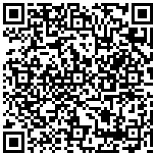

Bridge Mentoring Handbook
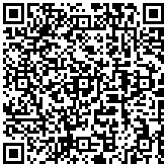

Creating Inclusive Campuses: The Impact of Disability Student Advocacy Clubs by Amanda Patrick, Megan Theobald, and Kiriko Takahashi https://rdsjournal.org/index.php/journal/article/view/1399 is licensed under a Creative Commons Attribution 4.0 International License. Based on a work at https://rdsjournal.org

