Review of Disability studies: an international journal | Volume 11, Issue 3

Editorial

Inclusion and the Gifts of Art
Maria T. Timberlake
RDS Associate Editor for Creative Works

On an early spring day in March 2015, I received the gift of song at the Museum of Fine Arts in Boston Massachusetts. The gift was offered as part of Sonic Blossom, an exhibit created by internationally acclaimed artist Lee Mingwei. The concept is that an opera singer wanders in the galleries and approaches random visitors asking, “May I give you the gift of song?” If the museum go-er accepts, they take the prepared seat in the gallery and the song is sung. In the photo below I am receiving the gift of song from Abby Krawson.

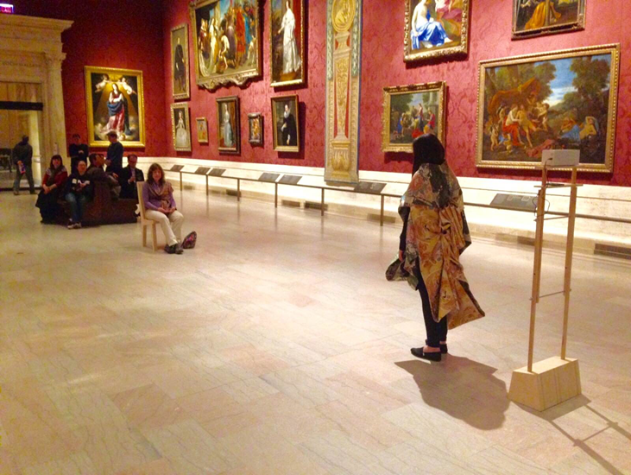
Figure 1 Photograph of the author receiving the gift of song from Abby Krawson
Mingwei refers to the song as “a transformative gift” and I can attest to the magical nature of this art. I was deeply affected by the beauty and intimacy of sitting in a majestic space and for a few minutes, being the singular focus of the singer and the song. Three months later, I was back in Boston on a sunny June afternoon to host Mingwei’s Living Room exhibit at the Isabella Stewart Gardner Museum. The exhibit invites the guest host to select objects of their own, with personal or aesthetic significance and bring them in to the museum. The host then shares her or his artifacts, telling the stories and engaging visitors in dialogues about the items. I received another unforgettable gift by being the “artist” for a day.

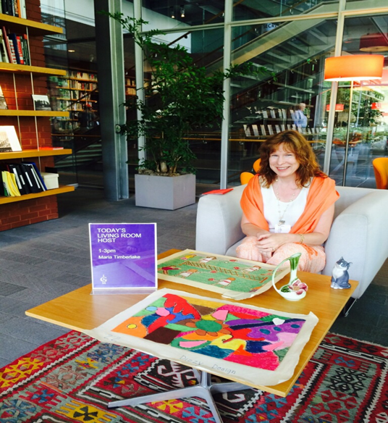
Figure 2 Photograph of the author hosting Mingwei's Living Room exhibit
Both of these experiences immersed my academic researcher-teacher self into a world of imagination, color, texture, music, and history. While Mingwei’s art is not about disability per se, his works are about human connection, paying sincere attention to others, and dissolving barriers between strangers. Mingwei’s work has been described as “a way to engage interaction and nurture participation” and these themes resonate deeply because I came to disability studies via inclusive education. For me, inclusion has always been an intuitive response to other human beings and cannot be reduced to an educational philosophy or placement decision based on evaluation results and classroom variables. Many disabled individuals, family members, advocates, and scholars have written eloquently about inclusion and the principles of openness and acceptance. I have been delighted to discover an individual who gives expression to the spirit of inclusion in visual and performance art.

The gifts I received at these exhibits continue to accrue and readers of RDS who have been inspired by music, literature or visual arts may understand the significance. Absorbing Mingwei’s art and reflecting on his unabashed desire to connect with his fellow human beings persuaded me to be more explicit about connection and love in my research and teaching. Mingwei has mended clothes and cooked meals for strangers in his performance exhibits. I saw how he dissolves barriers, deliberately reverses roles and undoes everyday structures of power and authority with beauty and gentleness. This vision of social barriers and social positions as malleable is vital to creating an inclusive world. Without any professional claim to the disability field, Lee Mingwei illustrated a counternarrative to the need for separation and I am still thinking about his honesty in seeking connection and his confidence in offering his time and service to strangers. Many educators have been conditioned to assess and evaluate people before offering participation but Mingwei did not stop to determine whether I possessed the prerequisite skills to be involved nor did he need to be assured that I would “benefit” in some practical way from being included.

The gifts of art I received strengthened my conviction that creative works and scholarly papers are a unique and vital combination here at RDS. One artist’s inclusive spirit provided me with an extraordinary experience that I treasure, and a deep thinking about my work that has remained long after the song was sung. If you know of an artist that you believe our readers might appreciate, consider crafting your own story. Or perhaps you have art to share? We publish visual images of paintings and sculpture, drawings and photographs as well as poetry and short story. Please join me and the editorial team here at RDS in bringing more gifts of art to our international readership.

Peace,
Maria T. Timberlake
maria.timberlake@cortland.edu

Lee Mingwei, Artist http://www.leemingwei.com/artist.php
Abigail R. Krawson, Soprano http://www.operabby.com/html/
http://www.leemingwei.com/projects.php
⁴ Gross, J. R. & Hyde, L. (2000).. Lee Mingwei: The living room. Published by the Trustees of the Isabella Stewart Gardner Museum. Two Palace Road Boston, MA 02115.

