Creative Works

Finding Becky: How Disability Erasure in Play Reflects and Influences Reality
Karin Hitselberger
The original version of this article was published on Claiming Crip (www.claimingcrip.com) under the title, Finding Becky: The Evolution of Barbie And the Importance of Representation

Abstract: This blog post examines the personal impact of disability representation in children’s toys, and explores how the story of a two decade old, discontinued, disabled doll mirrors the experiences of disabled people in society today.

Keywords: Toys, Representation, Popular Culture

I'm a big fan of nostalgia. I love things like Throwback Thursday and Flashback Friday. I love almost anything that brings back good memories, especially fond memories of my childhood. Whether it’s watching classic Disney movies and Nickelodeon shows on Netflix, picking up an old favorite snack when I happen to see it at the store after a particularly rough day, or giggling with my sister or my friends over the numerous Internet articles and quizzes extolling the virtues of 90s kids, I definitely enjoy the occasional blast from the past.

So, you can imagine how excited I was when my mom decided to surprise me with some 90s Barbie dolls to decorate my office, but these weren't just any Barbie dolls. My mom got me three different versions of Becky, the wheelchair-using friend of Barbie, an absolute favorite from my childhood.
My first exposure to Becky was Christmas of 1996 when my sister, all my cousins, and I received the doll as a Christmas present from my mother. I remember everybody loved her. She wasn't a "special" toy somehow reserved only for disabled girls. Anyone could play with Becky, and they did. I remember my friends loved that doll because unlike most Barbie dolls her legs were bendable so that she could sit in her wheelchair. Everyone loved her, but she was special to me.
Problematic or not, Barbie dolls matter because they often reflect the hopes and dreams of the little girls who play with them. That's why Barbie can simultaneously be an astronaut, a teacher, a movie star, a doctor, an Olympian, and a scientist, just to name a few. Barbie often reflects for little girls who they are and what they want to be when they grow up, which is why I was so excited to see the recent release of Barbie dolls that reflect a larger range of body types and skin tones, and it is why I treasured my Becky doll as a little girl. It is why I wish she still existed.
Becky mattered because she showed everyone that a wheelchair was nothing to be afraid of, and it didn't prevent you from having a life just like everybody else. Becky was a school photographer, a cheerleading coach, and even a Paralympian. Becky was part of Barbie's world, even if it wasn't made for her. The original version of Becky had to be redesigned because of technical difficulties and not being able to fit into the elevator of the dream house. Eventually, she was discontinued.
There has never been an official statement as to why Mattel stopped making Becky; in fact, it is incredibly difficult to find any official information on Becky at all. However, the prevailing theory seems to be that Becky was discontinued because she didn’t fit into Barbie’s world, and it was easier to get rid of her than to change everything else.

Whether or not this is the true reason, Becky's departure matters, because the truth is Becky didn’t fit into Barbie’s world, and there hasn’t been a Barbie in a wheelchair since. It matters because Becky's discontinuance reflects how we are often taught to think about disability, in terms of fixing people rather than society. It matters because it echoes a way of thinking that suggests people are problematic when they are different, instead of a realization that it is impossible to have a world where everyone is the same.
Becky's absence matters. Her redesign matters. Her presence mattered. All of it matters, because representation matters. It is important for disabled toys to exist because it reinforces the idea that disabled people are a natural part of the world, just like everybody else. Their absence in fantasy worlds teaches as much as their presence. Becky mattered because she was there, she did not have a passive role, she was a friend, an active part of Barbie’s world. Becky matters because she was shown as someone with hopes, dreams, and aspirations. Becky matters because she was thrust into a world that was quite literally not designed for someone like her.
Becky matters because I am Becky and when I was seven years old seeing a doll that looked like me was the most powerful thing in the world. Becky matters because representation in toys and mainstream media is so important because it shows that disability is nothing to hide or be afraid of. Becky matters because of the dream house. Becky matters because, instead of trying to fix disability, we should be trying to live in a world that is accessible to all people, no matter who they are.
Representation in toys is so important, but in order for it to make a difference, it has to be real. Having a doll in a wheelchair sends a great message to disabled and nondisabled children alike, but if that doll cannot fully participate in the fantasy society it is a part of, it just reinforces the message that disabled people are different and that disability is problematic.
If you have a doll like Becky in a wheelchair, but you have to take her out of the wheelchair to really be able to play with her in the dream house or the Barbie car, it continually sends the message that Becky's wheelchair is the problem. It promotes the idea that if we were able to get rid of her wheelchair Becky would be able to fit into Barbie's world.
Becky matters because we need to stop being afraid to redesign the dream house. We still live in a world where so many people feel like Becky in their everyday lives, the girl who is excluded because she does not fit into the dream house. I know I do. I constantly get the message that I am the problem, because I do not fit. Disability is so often thought of as "my problem" and "my responsibility".
Instead of creating an inclusive society where disability does not have to mean sitting out of life, so many people are focused on eradicating disability altogether. I will admit that I am ambivalent about whether or not I would cure my disability if I had the opportunity, but I will also say that I would rather have equality than a cure every single day of the week.
I am not a problem that needs to be fixed. I cannot and do not need to get rid of my wheelchair to fit into this world. Instead, I need to work on fighting for a world that understands that disability is just part of our natural diversity, and we need to create an environment that is accessible to all people.
I live in a world that regularly ignores my existence without even realizing it. I live in a world where finding truly accessible housing is about as common as finding a magical pink unicorn. I live in a world where staying at home in my parents’ house and never really going anywhere is still consistently offered as an acceptable solution to inaccessibility. I live in a world where my very existence is still seen as a problem. I live in a world where so many people's perspective on the ultimate solution to inaccessibility is to get rid of disability altogether.
It may seem like it is just a toy, but the dream house matters. The dream house matters because real accessibility is not optional it is essential. The dream house matters because we need to change the dream house! We need to realize that accessibility is possible, and instead of trying to change people to fit into our world, we need to change the world. The dream house matters because Becky was not the problem, the inaccessible environment was. I want to live in a world where we fight to change the dream house, instead of trying to change the people in it.

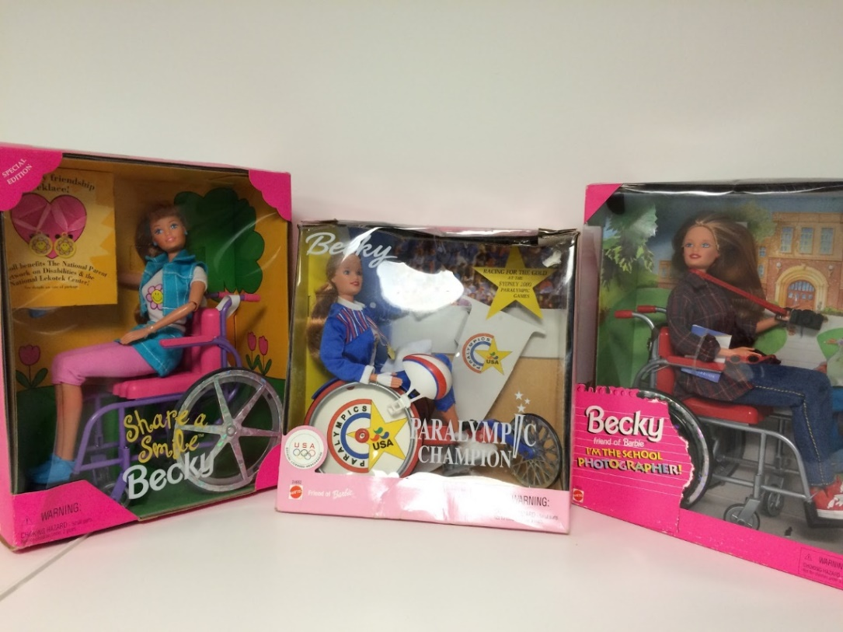
Photo Description:
Photos of three Barbies: Share a Smile Becky, Paralympic Champion Becky, and Becky, I’m the School Photographer.

Karin Hitselberger is an internationally known and award-winning blogger who focuses on the intersection of popular culture and disability. She blogs at www.claimingcrip.com and is deeply interested in how representations of disability in media and popular culture influence the psychosocial well-being of disabled people. Hitselberger received her BS Communication Studies and BS Religious Studies, University of Miami PG Dip. Disability Studies, University of Leeds.

